A

PROJECT REPORT

ON

ENHANCED E-HR MANAGEMENT SYSTEM

submitted in partial fulfillment of the requirement of the degree of

**BACHELOR OF ENGINEERING**

**IN**

**COMPUTER ENGINEERING**

BY

Armaan Nakhuda (20220164402277961)

Sushant Navle (2022016402277791)

Samay Pandey (202216402279163)

Peeyush Karnik (2021016402104651)

Guide

Prof. Vedika Patil



**Department of Computer Engineering**

K.C. College of Engineering and Management Studies And

Research, Thane (E)

University of Mumbai

2023-24

CERTIFICATE

This is certify that the mini project entitled **“ENHANCED E-HR MANAGEMENT SYSTEM’’** is Bonafide work of **Armaan Nakhuda (B-02); Sushant Navle (B-05); Samay Pandey (B-09); Peeyush Karnik (B-57)** submitted to the University of Mumbai in partial fulfillment of the requirement for the award of the degree of **“Bachelor of Engineering”** in **“Computer Engineering”.**

Guide

Prof. Vedika Patil



Head of Department Principal

Dr. Mahesh Maurya Dr. Vilas Nitnavare

**Project Report Approval for S.E.**

This mini project entitled ***ENHANCED E-HR MANAGEMENT SYSTEM*** by ***Armaan Nakhuda (B-02); Sushant Navle (B-05); Samay Pandey (B-09); Peeyush Karnik (B-57)*** is approved for the degree of Bachelor of engineering in Computer Engineering.

Examiners

1..............................................................................

(Internal Examiner Name & sign)

2.....................................................................

(External Examiner name & sign)

Date: -

Place: -

DECLARATION

We declare that this written submission represents our ideas in our own words and where others' ideas or words have been included, we have adequately cited and referenced the original sources. We also declare that we have adhered to all principles of academic honesty and integrity and have not misrepresented or fabricated or falsified any idea/data/fact/source in our submission. We understand that any violation of the above will be cause for disciplinary action by the Institute and can also evoke penal action from the sources which have thus not been properly cited or from whom proper permission has not been taken when needed.

[Armaan Nakhuda (20220164402277961) 02] ____________

[Sushant Navle (2022016402277791) 05] ____________

[Samay Pandey (202216402279163) 09] ____________

[Peeyush Karnik (2021016402104651) 57] ____________

(Signature)

Date: -

**ACKNOWLEDGEMENT**

We would like to express special thanks of gratitude to our guide **Prof. Vedika Patil** who gave us the golden opportunity to do this wonderful project on the topic of **Enhanced E-HR system**, which also helped us in doing a lot of research and we came to know about so many new things. We are very grateful to our Head of the Department **Dr. Mahesh Maurya** for extending his help directly and indirectly through various channels in our project work**.** We would also like to thank Principal **Dr. Vilas Nitnaware** for providing us the opportunity to implement our project. We are really thankful to them. Finally, we would also like to thank our parents and friends who helped us a lot in finalizing this project within the limited time frame.

Thanking You.

**TABLE OF CONTENT**

**Sr. No. Topic Page No.**

**Certificate i**

**Approval Sheet ii**

**Declaration iii**

**Acknowledgement iv**

**List of Figures vi**

**Abstract viii**

**List Of Abbreviations xi**

**1. Introduction**

**1.1 Introduction 1**

**1.2 Motivation 2**

**1.3 Problem Statement & Objectives 3**

**2.**  **Literature Survey 5**

**3. Proposed Work**

**3.1 Requirement Analysis 7**

**3.1.1 Scope 7**

**3.1.2 Feasibility Study 8**

**3.1.3 Hardware And Software Requirements 9**

**3.2 Architecture 10**

**3.3 Flowchart 11**

**3.4 Mini Project Contribution 12**

**3.5 Experimental Results 13**

**4. Conclusion and Future Scope 63**

**5. References 64**

List Of Figure

|  |  |  |
| --- | --- | --- |
| **Figure**  **no.** | **Figure Name** | **Page no.** |
| 3.3.1 | Flowchart | 11 |
| 3.5.1 | Main Login | 13 |
| 3.5.2 | Credits Dialog | 14 |
| 3.5.3 | Admin Window | 15 |
| 3.5.4 | Create/Remove Login | 16 |
| 3.5.9 | Approve Resignation | 18 |
| 3.5.10 | Admin Profile | 19 |
| 3.5.11 | HR Window | 20 |
| 3.5.12 | Employee Management | 21 |
| 3.5.19 | Approve/Grant Bonus | 25 |
| 3.5.26 | Approve Resignation | 28 |
| 3.527 | Check Employee Hours Attended | 29 |
| 3.5.28 | Create Survey | 30 |
| 3.5.30 | Approve Promotion | 31 |
| 3.5.31 | Apply for Resignation | 32 |
| 3.5.33 | Approve Review | 33 |
| 3.5.36 | Review Complaint | 35 |
| 3.5.37 | View Survey Results | 36 |
| 3.5.39 | HR Profile | 38 |
| 3.5.40 | Manager Window | 39 |
| 3.5.41 | Performance Review Approval | 40 |
| 3.5.43 | Approve Leaves | 42 |
| 3.5.48 | Apply for Resignation | 45 |
| 3.5.49 | Assign Promotion | 46 |
| 3.5.53 | Approve Resignation | 48 |
| 3.5.56 | Request bonus | 50 |
| 3.5.59 | Submit Performance Review | 52 |
| 3.5.60 | Manager Profile | 53 |
| 3.5.61 | Employee Window | 54 |
| 3.5.62 | Apply for Leave | 55 |
| 3.5.65 | Apply for Resignation | 57 |
| 3.5.67 | View and Submit Survey | 58 |
| 3.5.69 | Submit Complaint | 59 |
| 3.5.71 | Submit Performance Review | 60 |
| 3.5.73 | Employee Profile | 61 |

**Abstract**

The Enhanced E-HR system is a comprehensive software application designed to streamline and enhance human resource management processes within an organization. The system employs a user-friendly graphical interface developed using Python, providing an easy experience for users. Key features include secure user authentication, role-based access control, and a responsive design that adapts to varying screen sizes.

The application integrates Firebase, a cloud-based database service, for secure storage and retrieval of user credentials. This ensures data integrity and allows administrators to manage user access and permissions efficiently. The system caters to different user roles, including administrators, HR personnel, Managers and employees, each with tailored functionalities.

The login interface serves as the gateway to the system, allowing users to access role-specific modules. The modular design facilitates easy future enhancements. Admins can manage system credentials through Firebase, ensuring a centralized and secure user management system

The HR, Manager and employee modules offer distinct functionalities tailored to the respective roles. These include access to employee records, performance evaluations, and administrative tasks. The system incorporates dynamic resizing of background images, providing a visually appealing and responsive user interface.

The project aims to improve HR management efficiency, reduce manual workloads, and enhance overall organizational productivity. By leveraging modern technologies, the Enhanced E-HR system contributes to the digital transformation of HR processes, promoting a more streamlined and effective approach to human resource management.­­ The efficiency of the project is 95%.

**List Of Abbreviation**

List of Abbreviations for Enhanced E-HR system:

1. HRMS: - Human Resource Management System
2. E-HR:- Electronic Human Resource
3. E-HRMS:- Electronic Human Resource Management System
4. DBMS: - Database Management System
5. DB: - Database
6. CPU: - Central Processing Unit
7. RAM: - Random Access Memory
8. UI: - User Interface
9. GUI: - Graphical User Interface

**1.INTRODUCTION**

1.1 Introduction

In the dynamic landscape of modern organizations, the effective management of human resources is paramount to achieving strategic goals and maintaining a competitive edge. The Enhanced E-HR system emerges as a comprehensive solution, seamlessly integrating technology and human resource management practices to streamline processes, enhance efficiency, and foster a more strategic approach to workforce management.

The Enhanced E-HR system serves as the central hub for all HR-related activities within an organization, providing a robust platform for managing employee information, recruitment, performance appraisal, training, and more. This system not only automates routine HR tasks but also empowers HR professionals with valuable insights through analytics, aiding in informed decision-making.

In this digital age, ENHANCED E-HR SYSTEM With the advent of technology it consolidates and centralizes employee data, providing a secure and accessible repository for personal details, qualifications, and performance records.

Facilitating employee development, the Enhanced E-HR system aids in planning, implementing, and tracking training programs to enhance skills and knowledge.

As organizations continue to recognize the strategic importance of their human capital, it emerges as a critical tool in fostering a positive employee experience, ensuring compliance with regulations, and driving organizational success. This introduction sets the stage for exploring the various dimensions and functionalities of the Enhanced E-HR system, ultimately contributing to the evolution of modern HR practices within the organization.

1

**1.2 Motivation**

The motivation behind the development of the Enhanced E-HR system stems from the growing need for organizations to optimize and modernize their human resource management processes. As businesses evolve in today's dynamic environment, efficient HR management becomes crucial for organizational success. Traditional manual methods are often time-consuming, prone to errors, and lack scalability. The Enhanced E-HR system aims to address these challenges by providing a comprehensive, user-friendly, and technologically advanced solution.

**1. Objectives**

* **Streamlining HR Processes:** The primary objective is to streamline various HR processes, including employee record management, performance evaluation, and administrative tasks. Automation reduces manual efforts, minimizes errors, and accelerates processes.
* **Enhancing User Experience:** The system is designed with a focus on user experience, employing a graphical interface for ease of use. Dynamic resizing of background images ensures a visually appealing and responsive platform, enhancing overall user satisfaction.
* **Role-Based Access Control:** Implementing role-based access control ensures that each user, be it an administrator, HR personnel, Manager, or employee, has access only to the functionalities relevant to their role. This enhances security and data privacy.

**2. Technology Stack:**

The use of technologies such as Tkinter for the graphical interface, Pillow for image processing, and Firebase for database management contributes to the system's robustness and scalability. The integration of Firebase ensures secure storage and retrieval of user credentials, aligning with modern cloud-based solutions.

2

**1.3 Problem Statements and Objectives**

Problem Statements: -

In contemporary organizational environments, traditional human resource management practices often face significant challenges, hindering operational efficiency and limiting the potential for strategic HR contributions. Manual processes, lack of centralized data management, and inadequate automation lead to inefficiencies, errors, and delays in critical HR functions. The absence of a streamlined system compromises data security, inhibits quick decision-making, and impedes the overall effectiveness of HR processes.

1. **Manual and Time-Consuming HR Processes:** Traditional HR management practices heavily rely on manual processes, leading to inefficiencies and delays. Tasks such as employee record management, leave approvals, and performance evaluations are time-consuming and error-prone, hampering the overall productivity of the HR department.
2. **Lack of Centralized Data Management:** Existing HR systems often suffer from fragmented data storage, making it challenging to maintain a centralized and cohesive repository of employee information. This fragmentation results in data redundancies, inconsistencies, and difficulties in extracting meaningful insights for strategic decision-making.
3. **Security Concerns and Unauthorized Access:** Many HR systems lack robust security measures, exposing sensitive employee information to potential breaches. The absence of proper authentication and authorization mechanisms allows unauthorized access to confidential HR data, posing a significant security risk for the organization.
4. **Inadequate Role-Based Access Control:** The absence of role-based access control exacerbates security concerns, as users often have unrestricted access to all system functionalities. This not only compromises data security but also violates the principle of least privilege, hindering the establishment of a secure and compliant HR environment.

3

Objective: -

**1. Streamlining HR Processes:**

* Develop a comprehensive Enhanced E-HR system that automates and streamlines routine HR processes, such as employee record management, performance evaluations, and administrative tasks.

**2. Enhancing Data Security:**

* Implement robust security measures, including secure user authentication and role-based access control, to ensure the confidentiality and integrity of sensitive employee information.

**3. Improving User Experience:**

* Design a user-friendly graphical interface with dynamic resizing capabilities to enhance the overall user experience, ensuring that the system is accessible and engaging for all users, regardless of their technical proficiency.

**4. Implementing Modern Technologies:**

* Utilize modern technologies such as Tkinter for the graphical interface, Pillow for image processing, and Firebase for database management to create a technologically advanced and scalable Enhanced E-HR system.

**5. Facilitating Digital Transformation:**

* Contribute to the organization's digital transformation by providing a platform that aligns with modern HR practices, encourages automation, and supports strategic decision-making.

**6. Role-Specific Functionalities:**

* Develop role-specific modules catering to the unique needs of administrators, HR personnel, Managers, and employees, ensuring that each user has access only to functionalities relevant to their role.

**7. Scalability and Future Enhancements:**

* Design the system with a modular architecture to allow for easy scalability and future enhancements, ensuring adaptability to evolving organizational requirements.

4

**2. Literature Survey**

1. State of the System: HRIS development: Project team guide to build effective personnel information system

Author: Walker A.J.

Year: 1982

Description: In 1982, Walker A.J. contributed significantly to the field of Human Resource Information Systems (HRIS) by providing a comprehensive project team guide. This guide aimed to streamline the development process, facilitating the creation of efficient and effective personnel information systems, thereby advancing HRIS development practices.

1. State of the System: Defined HRM as those involved in complex decision.

Author: Beer et al.

Year: 1984

Description: In 1984, Beer et al. presented a seminal definition of Human Resource Management (HRM), emphasizing its critical role in navigating complex decision-making processes within organizations. Their definition laid a foundational understanding of HRM, highlighting its multifaceted nature and strategic importance.

1. State of the System: Calculating return on investment on HR

Author: Robert B.

Year: 1999

Description: Robert B.'s contribution in 1999 underscored the increasing importance of quantifying the impact of HR practices on organizational performance. By advocating for the calculation of return on investment (ROI) in HR initiatives, he encouraged organizations to adopt a more strategic approach to human capital management, acknowledging HR's potential to drive tangible business outcomes.

5

1. State of the System: Becker workforce of card management Human capital to execute strategy

Author: Hufelid, M.A.

Year: 2005

Description: In 2005, Hufelid, M.A. expanded upon Becker's seminal work by delving into the intricate realm of workforce card management. By elucidating the critical role of human capital in strategy execution, Hufelid emphasized the need for organizations to effectively manage and leverage their workforce to achieve strategic objectives, thereby enriching the discourse on human capital management practices.

1. State of the System: Strategic HR management

Author: Behuselid

Year: 2006

Description: Behuselid's exploration of Strategic HR Management in 2006, as documented in the Journal of Management, provided valuable insights into the strategic dimension of HR practices. By elucidating the strategic role of HR in organizational management, Behuselid contributed to a deeper understanding of how HR initiatives can be aligned with broader organizational objectives, thus paving the way for more effective strategic HR management practices.

6

**3.Proposed Work**

3.1 Requirement Analysis

Traditional HR practices face challenges in efficiency and security. Our proposed Enhanced E-HR system introduces automation, centralized data management, and robust security measures. With a user-friendly interface and modern technologies, the system aims to streamline operations, enhance data integrity, and align with organizational digital transformation goals, empowering HR professionals for organizational success.Top of Form

3.1.1 Scope

Inefficient and disjointed human resources (HR) management processes within the organization hinder productivity, compliance, and employee engagement. Manual handling of tasks such as employee data management, payroll processing, leave tracking, and performance evaluations results in errors, delays, and suboptimal decision-making. Lack of a centralized Enhanced E-HR System leads to data fragmentation, compliance risks, and difficulty in accessing real-time insights for strategic workforce planning. Moreover, the absence of streamlined communication channels and self-service options undermines employee satisfaction and engagement levels. To address these challenges and enhance organizational efficiency, there is a critical need for the implementation of a comprehensive Enhanced E-HR Management 9System that integrates seamlessly with existing workflows, ensures regulatory compliance, empowers employees, and enables data-driven decision-making processes.

7

3.1.2 Feasibility Study

1. **Technical Feasibility:**
2. Python latest module required.
3. Internet access required.

**2. Economic Feasibility:**

1. Development costs are manageable within the allocated budget.
2. Firebase is cost efficient database to use.

**3. Operational Feasibility:**

1. The project aligns with the organization's capabilities and resources.
2. Integration into existing operations is feasible.

**4. Legal and Regulatory Feasibility:**

1. No significant legal barriers are foreseen, and compliance.

**5. Scheduling and Time Feasibility:**

1. Project timelines allow for timely development and deployment.

8

3.1.3 Hardware and Software Requirements: -

Hardware: -

1. Minimum Requirements:
2. Processor: - Dual core processor @2.4Ghz
3. Ram: - 4GB Ram
4. Storage: - 2GB free space
5. Internet: - speed: 3mbps
6. Recommended Requirements:
7. Processor: - Quad core processor @2.8Ghz
8. Ram: - 8GB Ram
9. Storage: - 4GB free space
10. Internet: speed: 6mbps

Software: -

1. Minimum Requirements:
2. OS: Windows 10 22H2
3. Python: Version 3.11 with pil, firebase, firebase_admin and tkcalendar modules installed
4. Recommended Requirements:
5. OS: Windows 11 22H2
6. Python: Version 3.12 with pil, firebase, firebase_admin and tkcalendar modules installed

9

3.2 Architecture

The Enhanced E-HR system aims to revolutionize HR processes for enhanced efficiency and streamlined operations. This report provides a comprehensive overview of the system architecture.

1. User Interface: -

1. Intuitive design for employee self-service and admin dashboards.
2. Responsive and user-friendly interface.

2. Database Management: -

a. Centralized database for secure storage of employee data.

b. Database management system for efficient data retrieval.

3. Application Logic: -

a. Employee Onboarding: Digital forms and document submission.

b. Attendance Tracking & Performance Records

c. Performance Management: Goal setting, feedback mechanisms.

d. Employee Self-Service: Leave requests and personal information.

4. Technologies Used: -

a. Frontend: Python

b. Database: Firebase

10

3.3 Flowchart: -

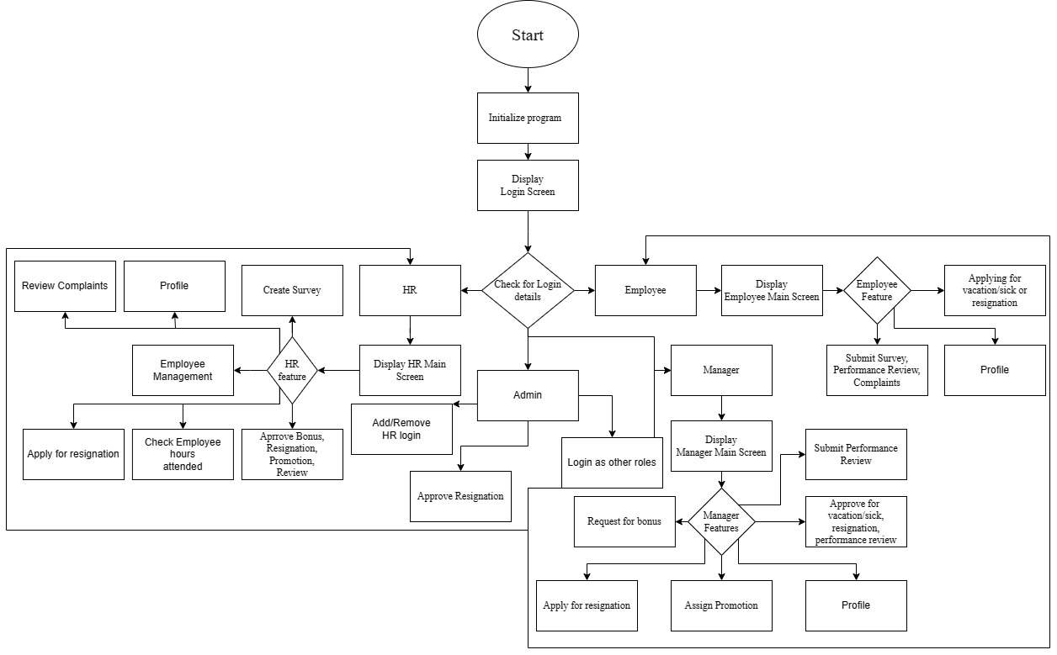

**Figure 3.3.1: Flowchart for Enhanced E-HR System**

Figure 3.3.1 is a flowchart of the basic showcase of Enhanced E-HR system.

1. Initialization: Login screen helps to identify if the user is Admin, HR, Manager or Employee.
2. Database: The user is then given the features with respect to its login details.
3. Features: These are differentiated between Admin, HR, Manager and Employee respectively.
4. Admin: This user can remove or add login details of HR/Manager/Employee, sign in as per what permission level is desired and approve resignation.
5. HR: This user can Add or remove manager/employee, manage salary and approve feedbacks, etc.
6. Manager: This user can View performance, approve for vacation/sick leaves or resignations, bonus or promotions, etc.
7. Employee: This user can apply for leaves, submit survey or apply for vacations, etc.

11

* 1. Mini Project Contribution

The workflow was divided and done by all the members of the project group, the work done by each member is as follows:

1. Armaan Nakhuda: Exit and Credits button on login screen

Resizing, centering, and focusing of all windows

Manager Window

50% of Employee window

Documentation and ppt (error checking)

Research Paper

1. Sushant Navle: Basic Login page and admin login screen (no buttons)

Documentation

PPT

Research Paper

1. Samay Pandey: Implementation and connection of DB

Dynamic name on every window

Admin window

HR window

50% of Employee window

Documentation and ppt (flowcharts error checking)

Research Paper

1. Peeyush Karnik: Documentation

PPT

12

* 1. Experimental Result: -

Main login: -

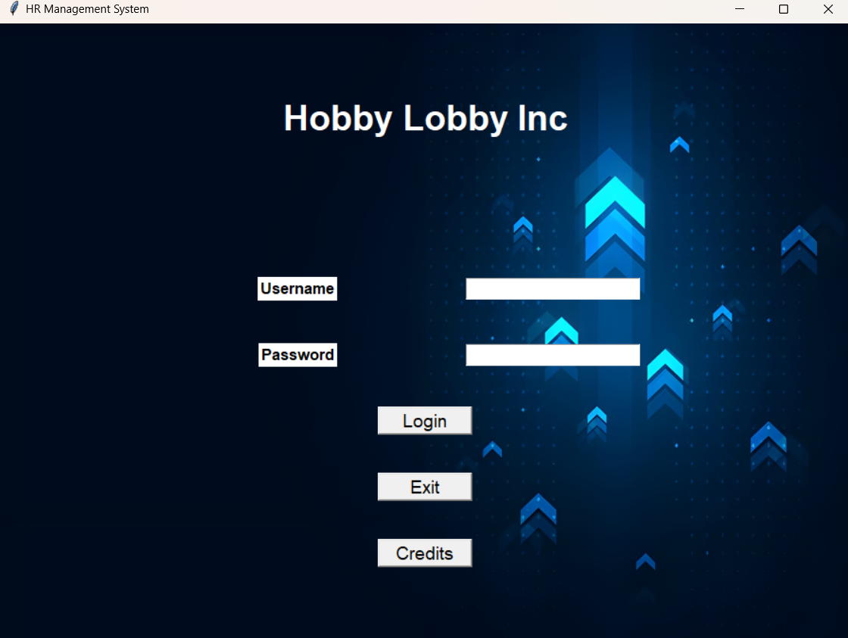

**Figure 3.5.1: main login page**

Figure 3.5.1: - The first page presented to the user upon opening the application, this page gives the input boxes to enter the username and password along with the login button and the exit and credit buttons.

There are 4 types of windows which will open following the user’s login depending on what role has been assigned the user in the DB, the 4 types of logins are Admin (figure 3.5.3), HR (figure 3.5.11), Manager (figure 3.5.40) and Employee (figure 3.5.61).

13

Credits Dialog box in main login screen: -

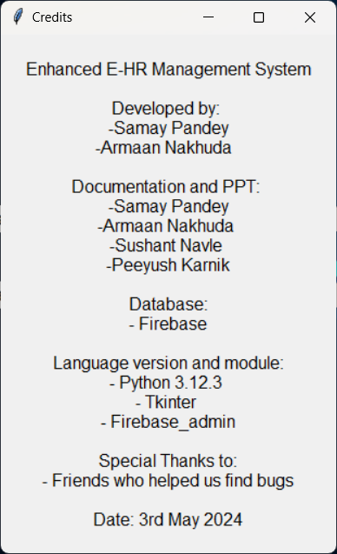

**Figure 3.5.2: credit Dialog box**

Figure 3.5.2: - The Credits dialog which opens after clicking the credits button on the main login page.

14

Admin Window: -

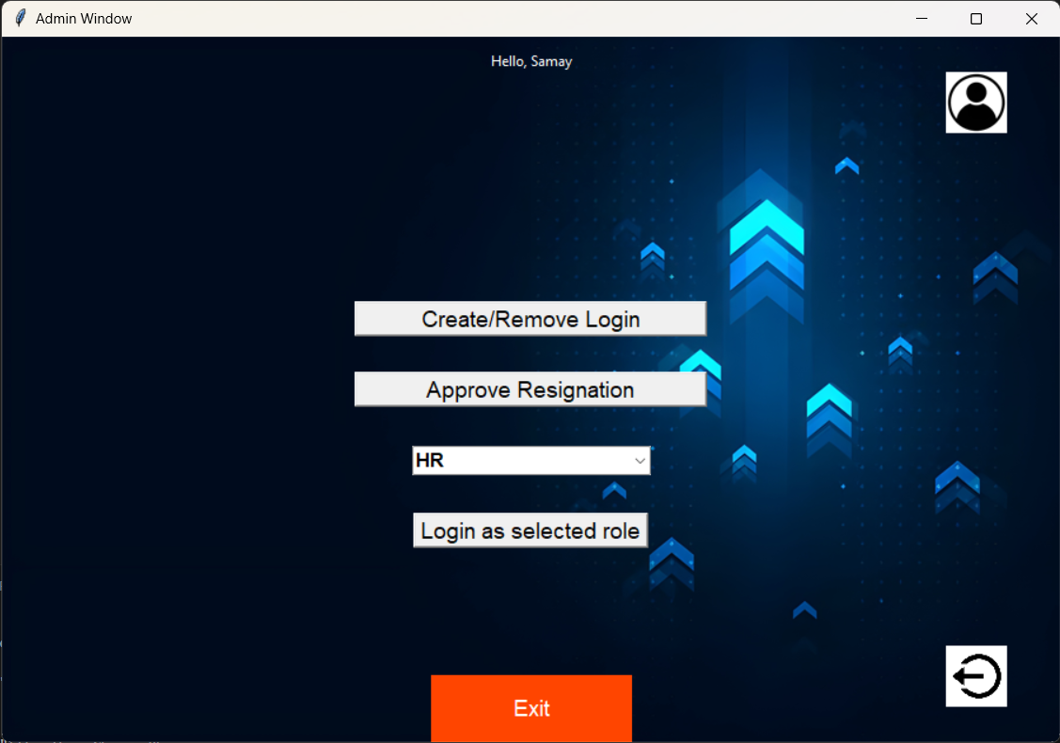

**Figure 3.5.3: Admin Window**

Figure 3.5.4: - This is the main admin window first presented to the user when they first login. It contains 2 main buttons which are Create/Remove Login which gives the admin the option to add or remove logins of HR, Manager or Employee and the Login as Selected Role button which gives the admin the option to simulate a different login level to test out issues in the application or the database. The page also contains the profile button which shows the details of the admin and the logout button which takes the user back to the login page.

15

Create/Remove Login: -

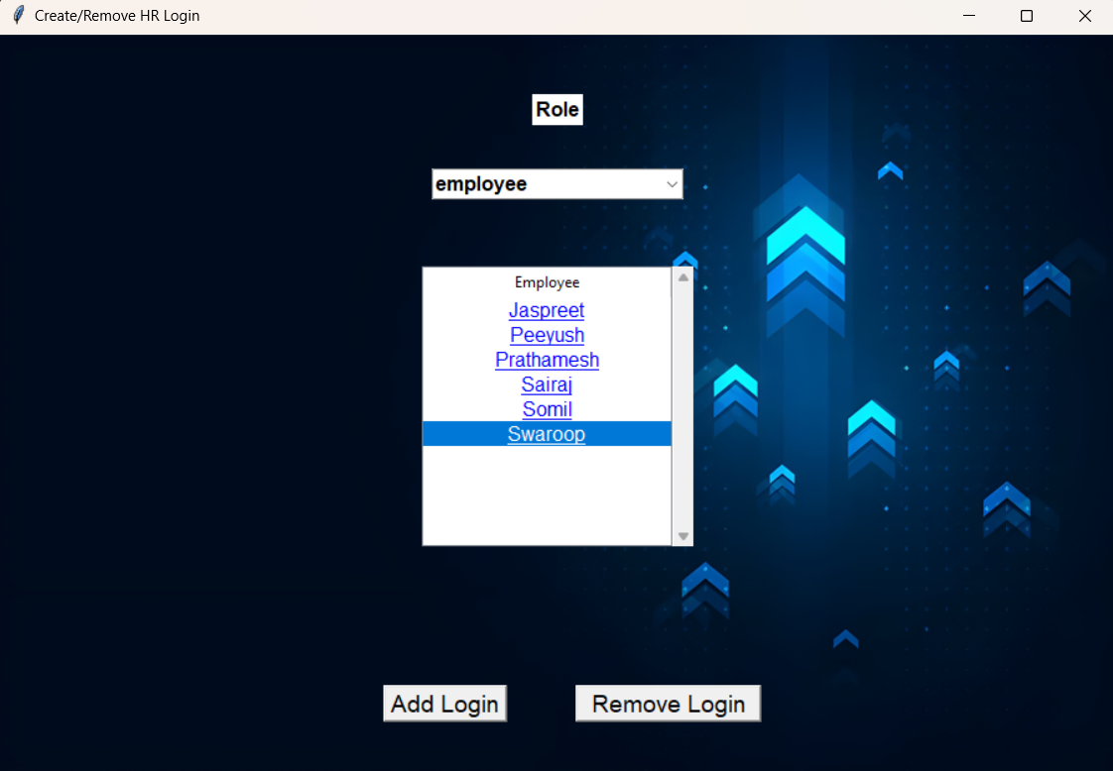

**Figure 3.5.4: Create and Remove Login**

Figure 3.5.4: - The first screen that is displayed to the user when the Create/Remove button is pressed, this screen gives the admin the option to select the category of role so the logins of that role are shown, upon it being shown the admin can select one role and delete it. (Figure 3.5.5 and 3.5.6).

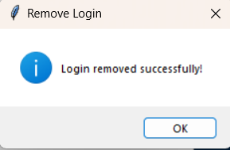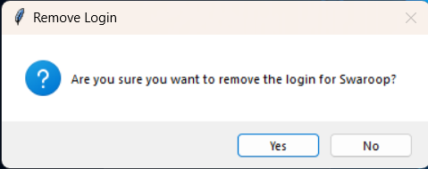Clicking the Add login button, opens a new window (Figure 3.5.7).

**Figure 3.5.5: Confirmation Dialog Figure 3.5.6: Success Dialog**

Figure 3.5.5 and 3.5.6: - Gives the confirmation and success popups for the removal of the login.

16

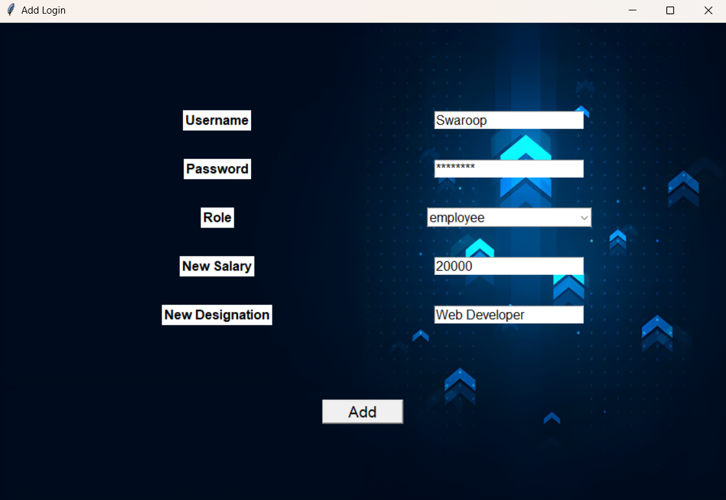

**Figure 3.5.7: New Login**

Figure 3.5.7: - Shows the window to provide details for the new login to be added to the DB.

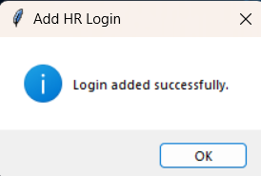

**Figure 3.5.8: Success Dialog**

Figure 3.5.8: - Shows the confirmation that the login has been added to the database successfully.

17

Approve Resignation: -

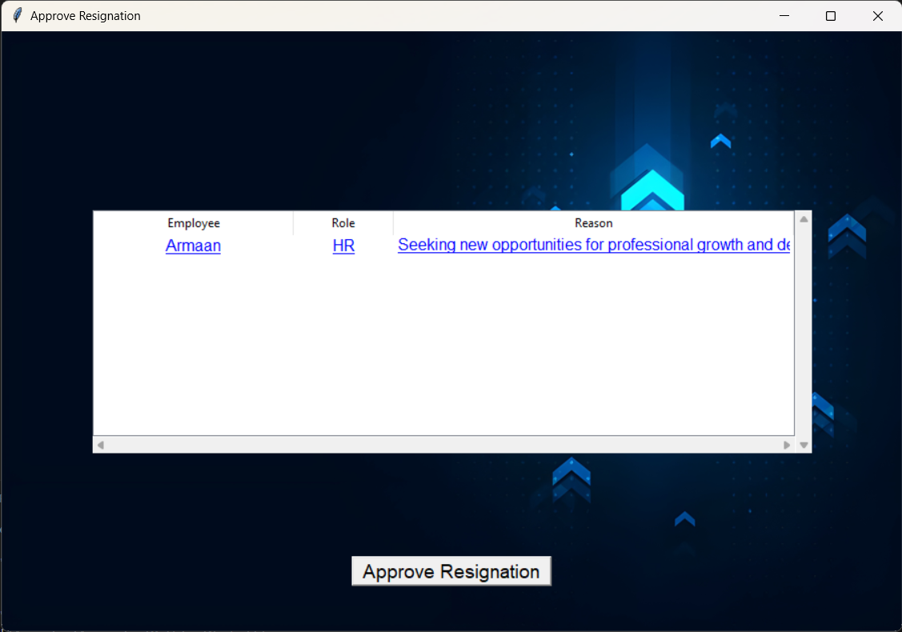

**Figure 3.5.9: Approve Resignation.**

Figure 3.5.9: - Here the admin role can approve for the resignation of a particular HR profile. It can review the details from the particular HR personnel such as their name and reason regarding their resignation.

18

Profile for Admin: -

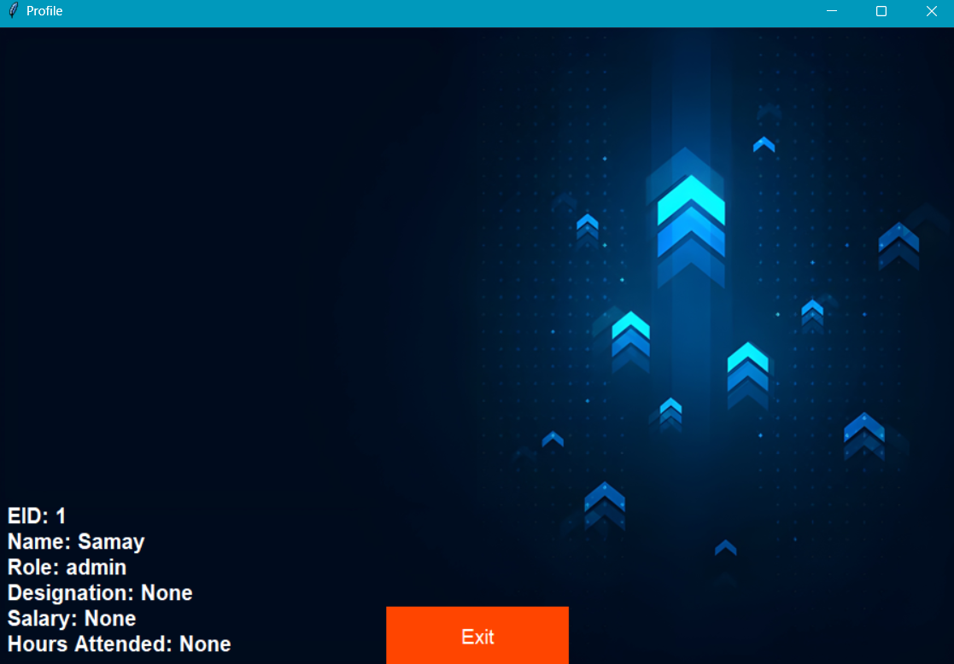

**Figure 3.5.10 Admin Profile**

Figure 3.5.10: - This Profile screen represents the details for the admin which shows the Name, EID, Role, Designation, Salary, Hours Attended, Bonus and Sick days leave/ Vacation days leave.

19

HR Window: -

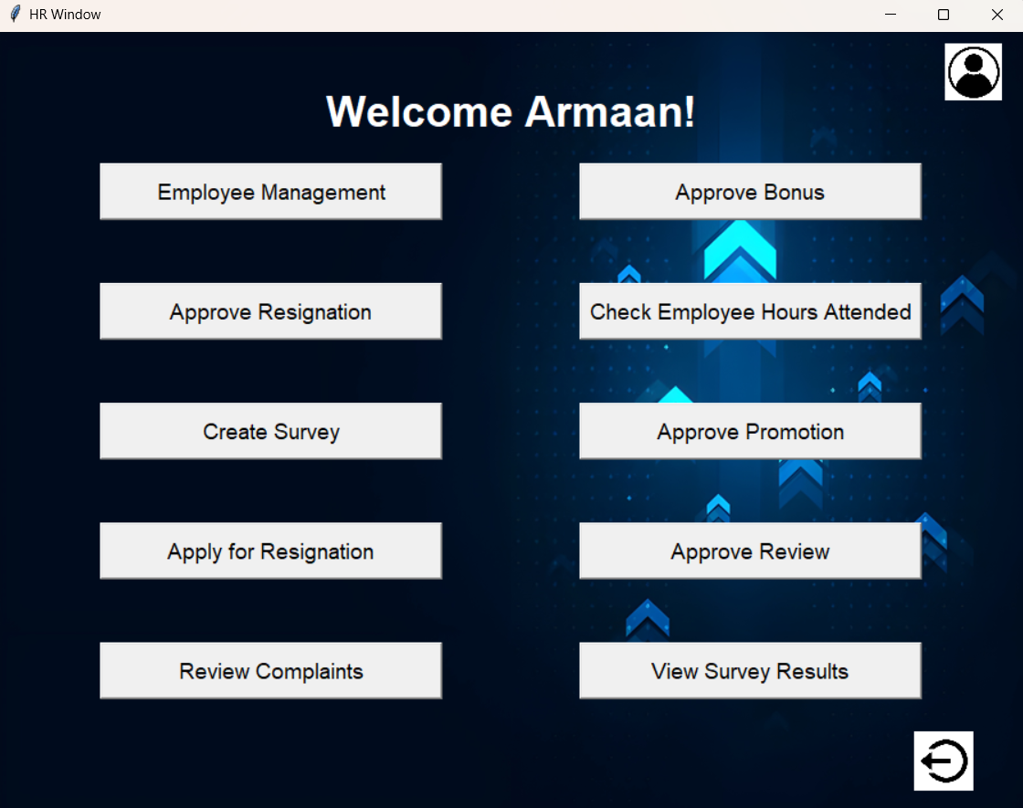

**Figure 3.5.11: HR Window**

Figure 3.5.11: - The first screen shown to the HR when the user logs in, it has buttons like employee management (figure 3.5.12) to manage Managers and Employees, Approve bonus to employees and grant bonus to managers (figure 3.5.19), approve resignations for Managers and employees (figure 3.5.26), check employee hours and warn them if their hours are low compared to what it should be (figure 3.5.27), send out survey with specified questions to the employees to be filled (figure 3.5.28), approve for promotion of employee (Figure 3.5.30), Apply for resignation (figure 3.5.31), Approve review for the employees and managers (figure 3.5.33), review complaints against employees (figure 3.5.36) and view the survey answers sent in by the employees (figure 3.5.37). The screen also has a profile button to view the details (figure 3.5.39) and a logout button which will take the user back to the login screen (figure 3.5.1).

20

Employee Management: -

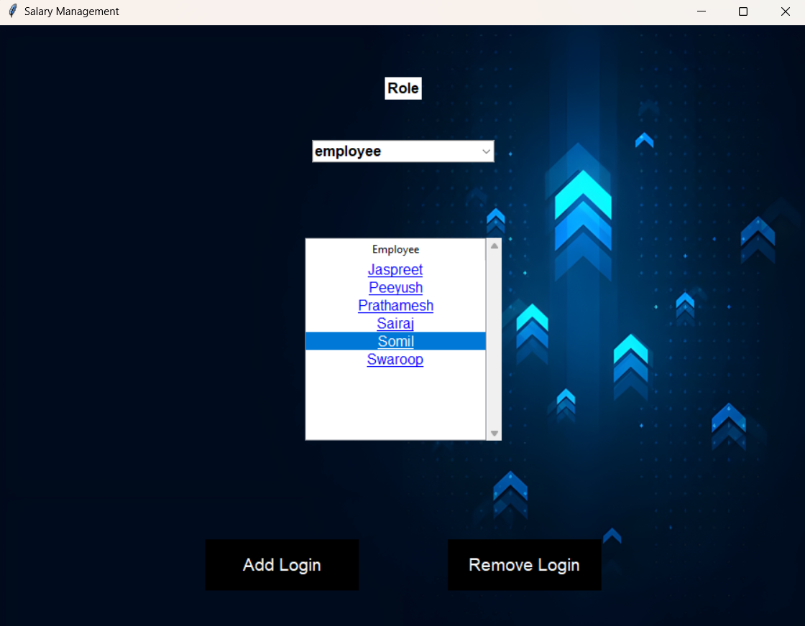

**Figure 3.5.12: Employee Management**

Figure 3.5.12: - When the Employee Management button is clicked, this window will appear to the user which includes a toggle to select the role between manager and employee, upon selecting the role all the logins within that role will show up in the list below, the user can then click on any name to show the details of the employee as shown in figure 3.5.13.

The add login button will open a new window which allows to input the details for the new login as shown in figure 3.5.7.

The remove login button will remove the selected login as shown in figure 3.5.17.

21

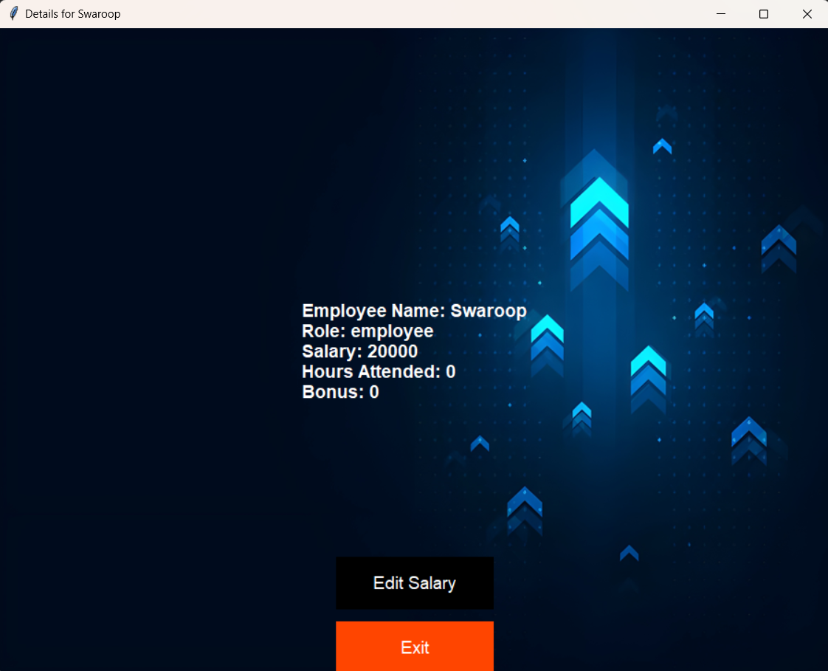

**Figure 3.5.13: Details of Employee**

Figure 3.5.13: - The details of the employee that was clicked is shown in a new window, along with the option to edit the salary for the employee.

22

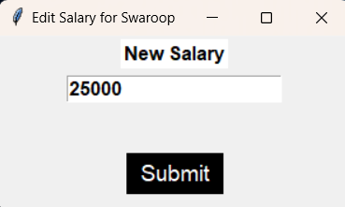

**Figure 3.5.14: Edit Salary**

Figure 3.5.14: - When the user clicks on edit salary button a new window will open asking for the input for the new salary of the Manager/Employee.

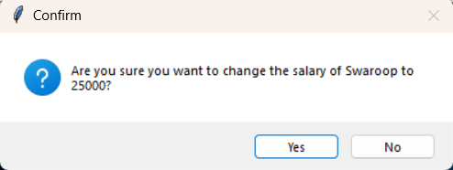

**Figure 3.5.15: Success Dialog**

Figure 3.5.15: - Shows the confirmation asking if the new salary is correct and this new salary should be uploaded the DB.

23

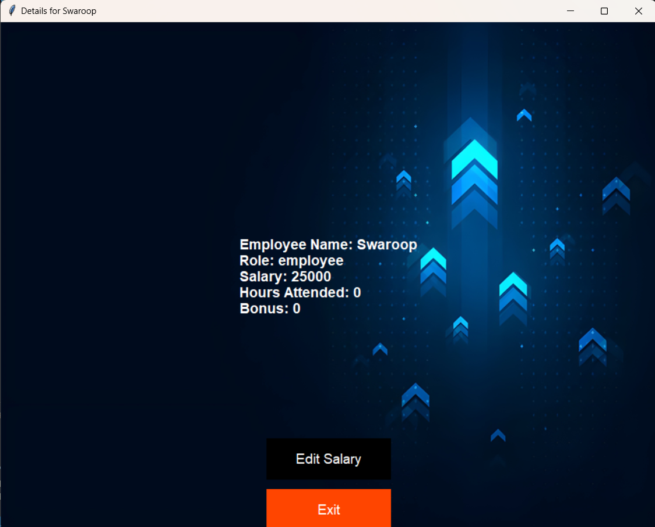

**Figure 3.5.16: Updated Salary**

Figure 3.5.16: - Shows the updated salary in the details window.

**Figure 3.5.17: Confirmation Dialog Figure 3.5.18: Success Dialog**

Figure 3.5.17 and 3.5.18: - Shows the Dialog box asking for confirmation and the success dialogs if the HR clicks on yes to delete the login of the user.

24

Approve Bonus: -

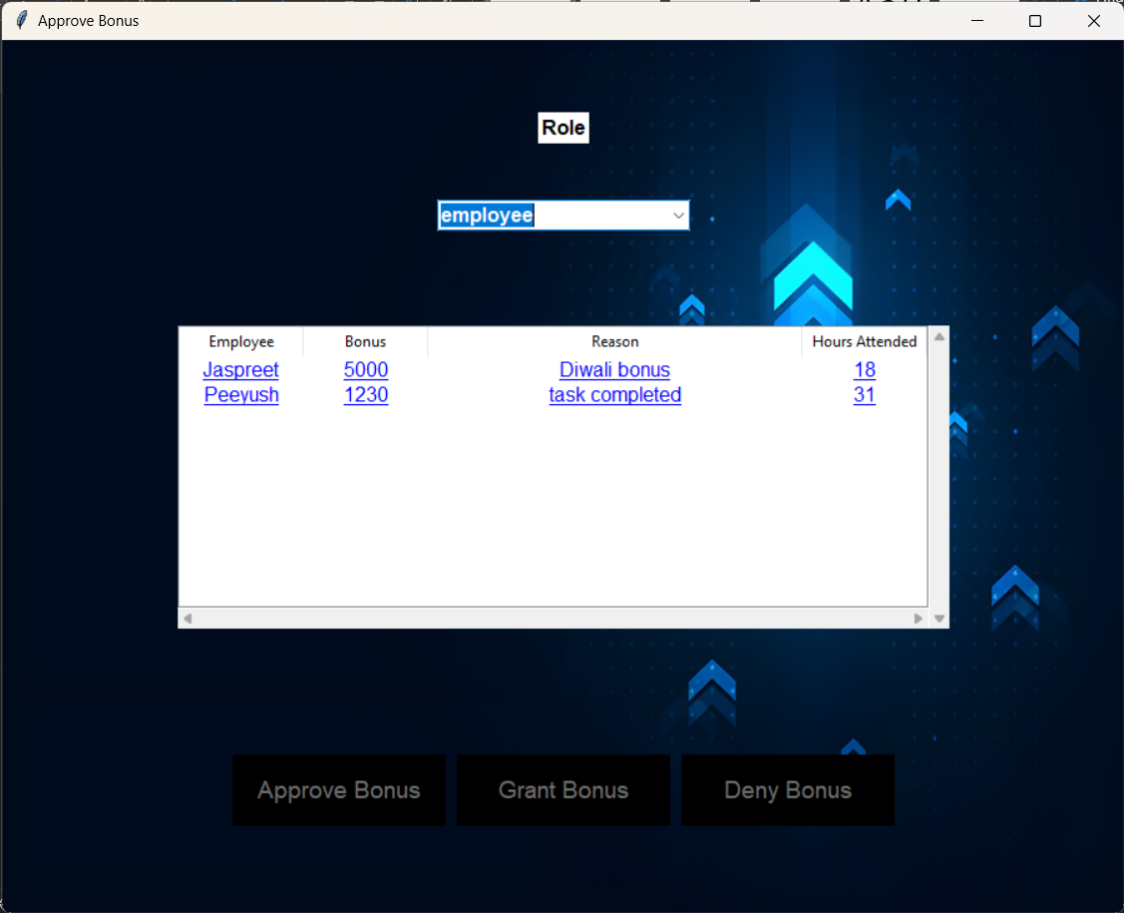

**Figure 3.5.19: Employee Bonus Request**

Figure 3.5.19: - The Employee bonus is requested by the Manager and has to be approved by the HR, giving the HR two options to either approve or deny the request.

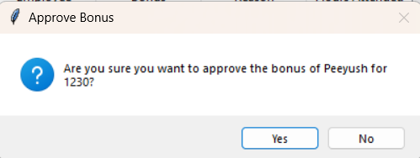 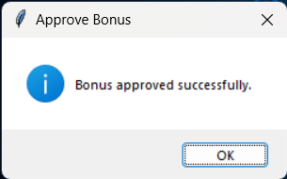

**Figure 3.5.20: Confirmation Dialog Figure 3.5.21: Success Dialog**

Figure 3.5.20: - When the approve or deny button is clicked another confirmation is displayed for the respective action.

Figure 3.5.21: - Shows the dialog box that the action has been completed and the update has been pushed into the DB.

25

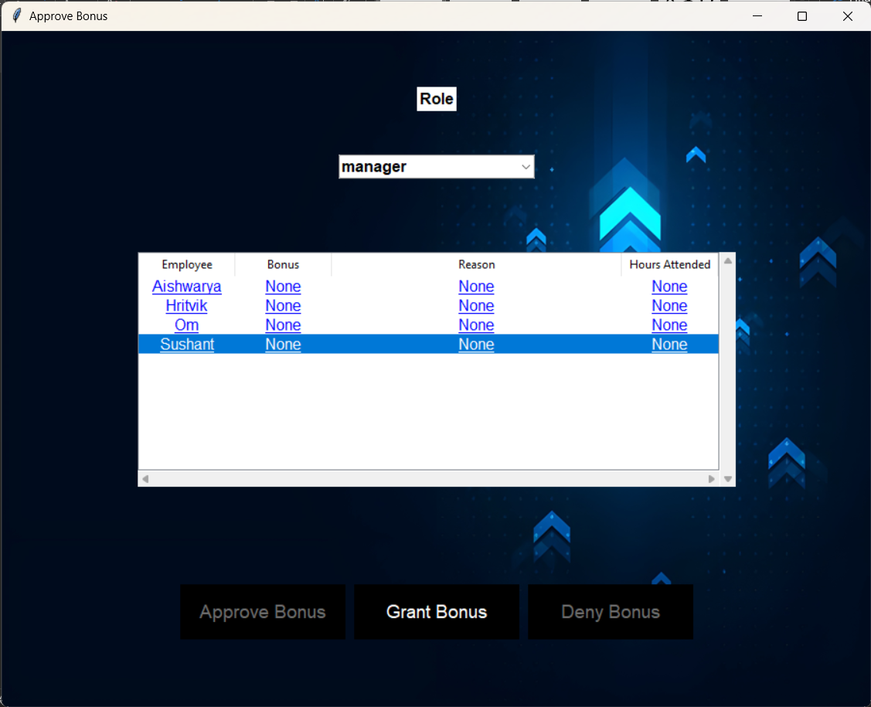

**Figure 3.5.22: Grant Bonus**

Figure 3.5.22: - For Manager level the HR directly grants bonus on their discretion, therefore the grant bonus option is available which when clicked opens a new window (figure 3.5.23).

26

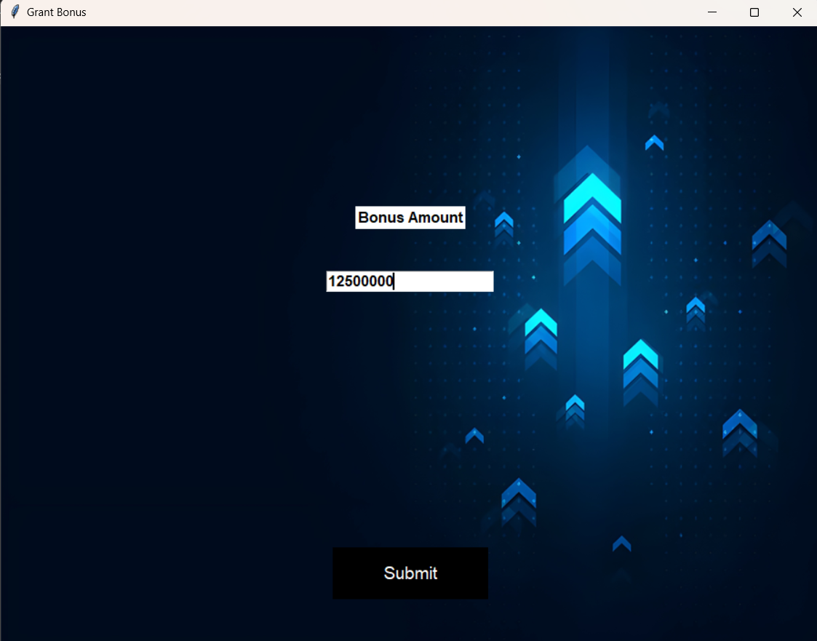

**Figure 3.5.23: Grant Bonus**

Figure 3.5.23: - Gives the HR the input box to input the amount of bonus that should be provided the specified Manager, on clicking the submit button is shown.

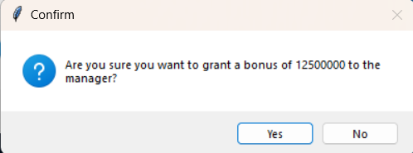 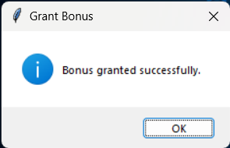

**Figure 3.5.24: Confirmation Dialog** **Figure 3.5.25: Success Dialog**

Figure 3.5.24 and 3.5.25: - The confirmation dialog is shown to the user, upon clicking yes, the details are updated into the DB and the success dialog is shown.

27

Approve Resignation: -

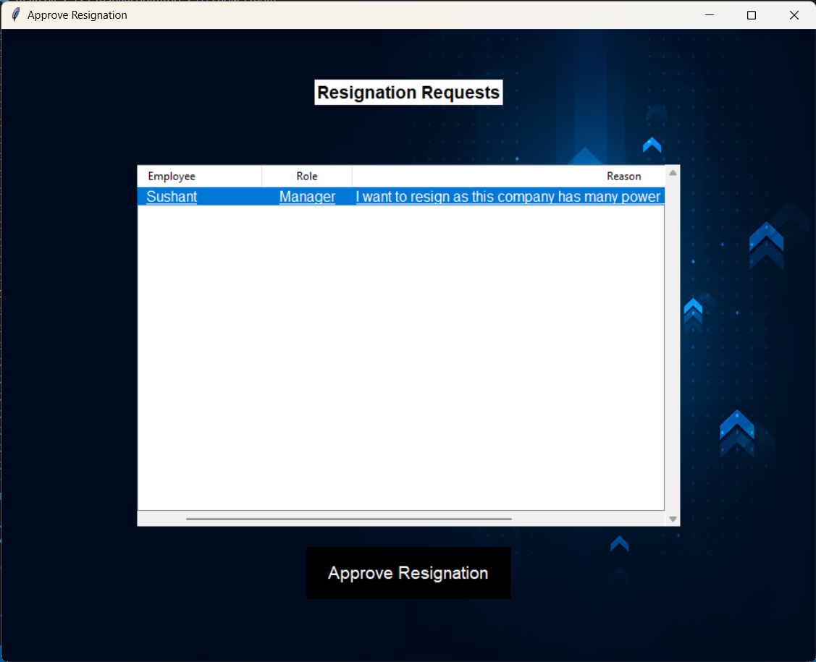

**Figure 3.5.26: Approve Resignation**

Figure 3.5.26: - Upon clicking the Approve resignation button a new window shows up with the list of employees whose resignation approval is pending, upon clicking the respective employee the approve button highlights itself which can then be clicked to approve the resignation.

28

Check Hours Attended: -

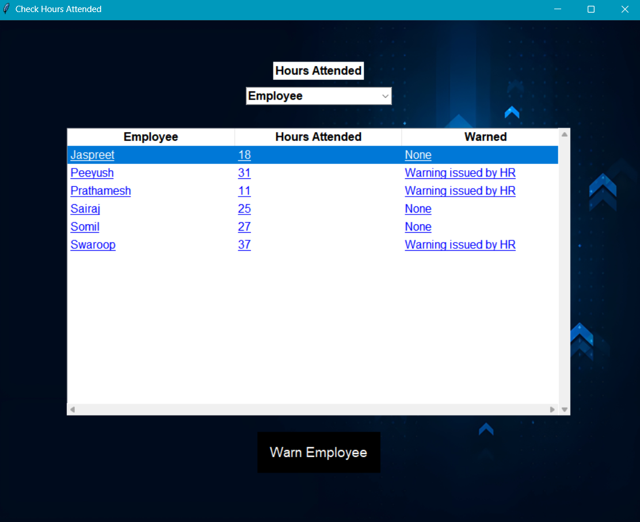  
**Figure.3.5.27: Check Hours Attended**

Figure 3.5.27: - This window represents the following employee list and there hours of attendance. Here we can observe the employees and manager as well for the hour of attendance. The HR can also issue a warning to the employee or manager regarding the respective matter directly to the particular person.

29

Create a Survey: -

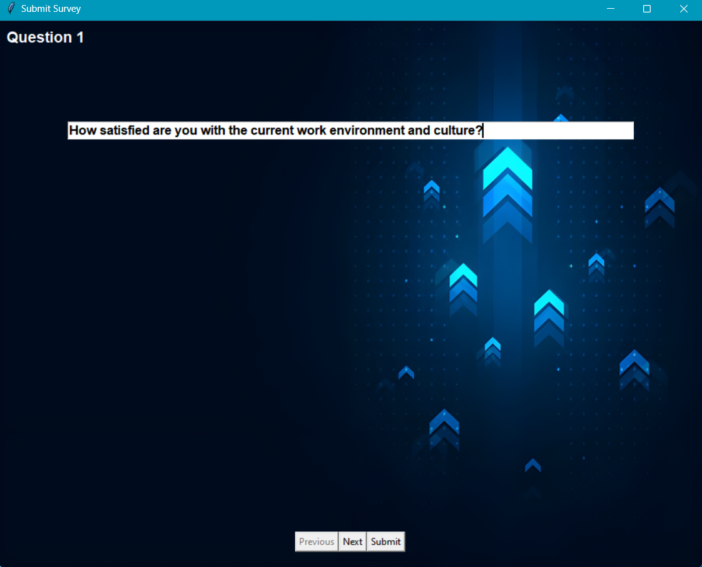

**Figure 3.5.28: Submit Survey**

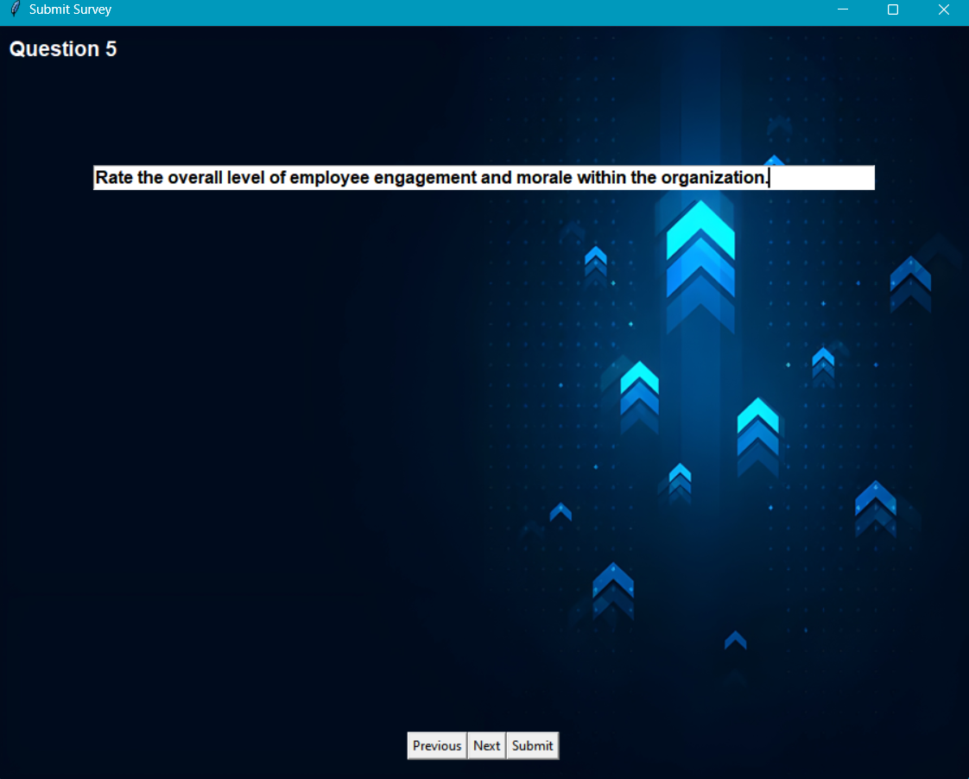

**Figure 3.5.29: Submit Survey**

Figure 3.5.28 and 3.5.29: Show the first and last question of the survey along with the previous next and submit buttons to move between the questions and to assign the survey for the employees to fill it.

30

Approve for promotion: -

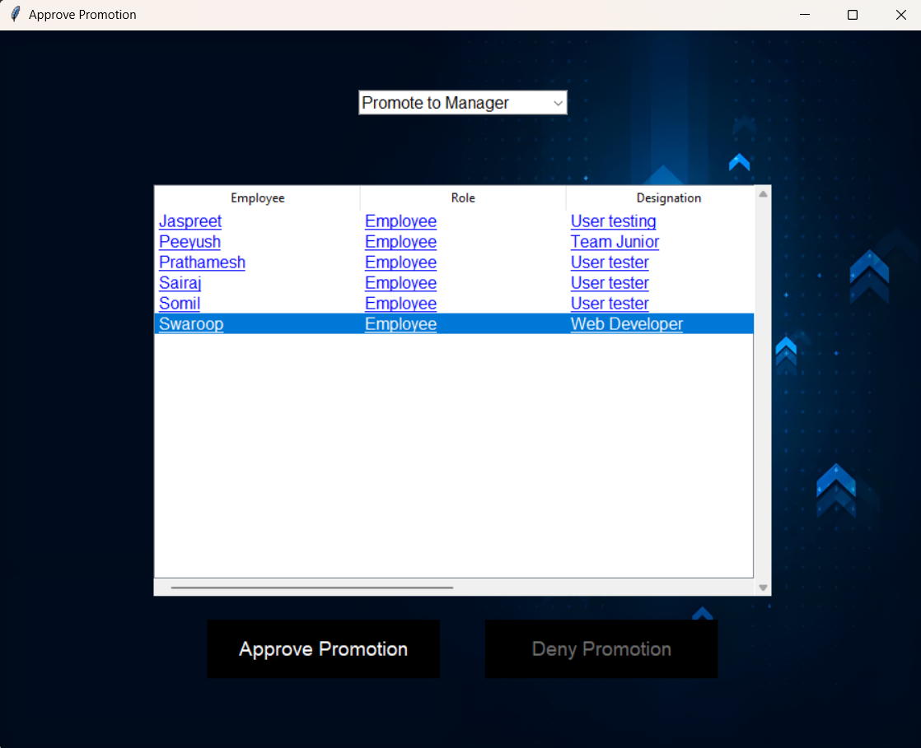

**Figure 3.5.30: Approve Promotion**

Figure 3.5.30: - Upon clicking the Approve promotion button a new window shows up with the list of employees whose promotion approval is pending, upon clicking the respective employee the approve button highlights itself which can then be clicked to approve the promotion.

31

Apply for Resignation: -

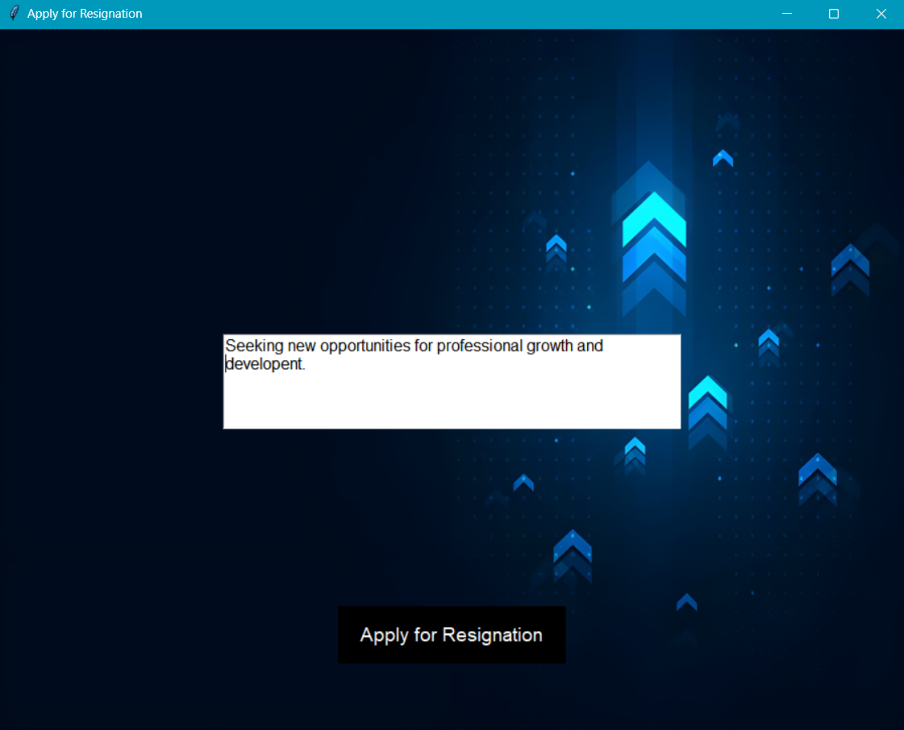

**3.5.31: Application for resignation**

Figure 3.5.31: - The window represents an application with which the HR can write a resignation with respect to whatever specific reasons he/she feels right.

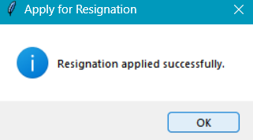

**Figure 3.5.32 Success Dialog for Resignation**

Figure 3.5.32: - This successful dialog is showed to the Employee profile user after applying for resignation.

32

Approve Review: -

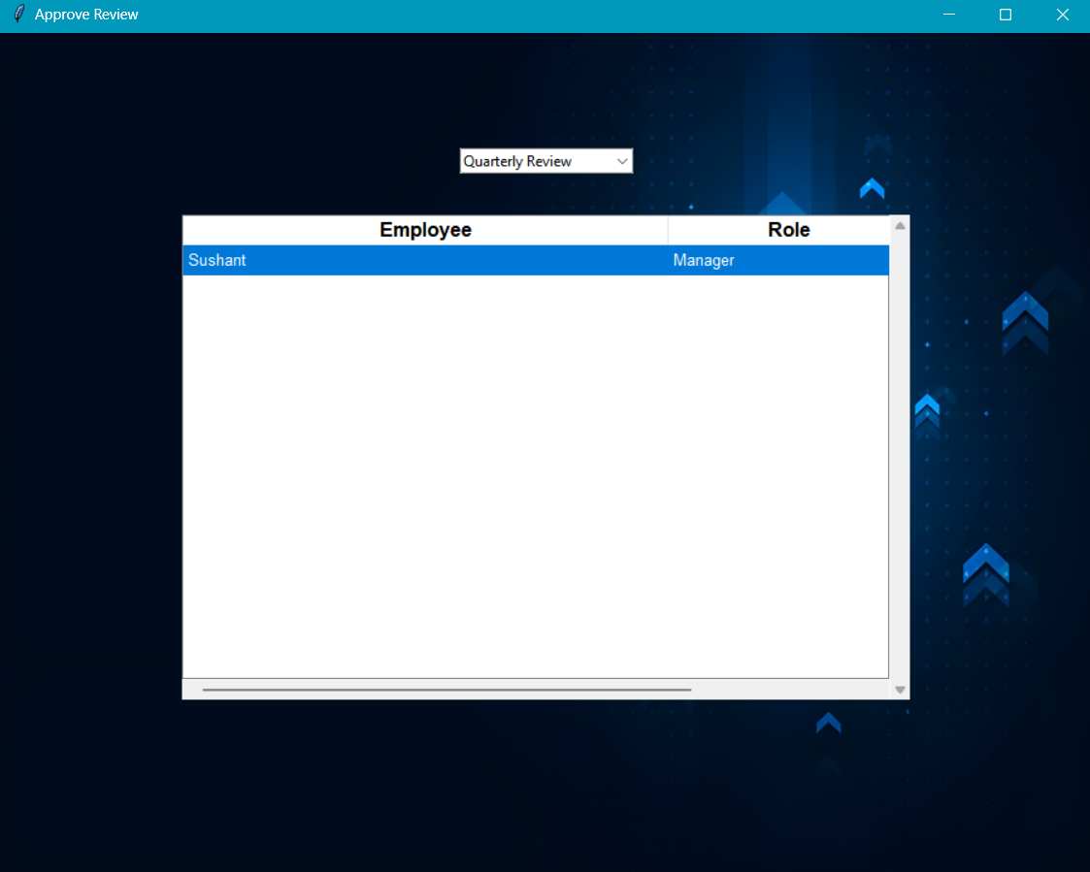

**Figure 3.5.33: Approve Review**

Figure 3.5.33: - Upon clicking the Approve Review the HR is able to view a menu which has an option of reviewing results with respect to Quarterly or Annual review.

33

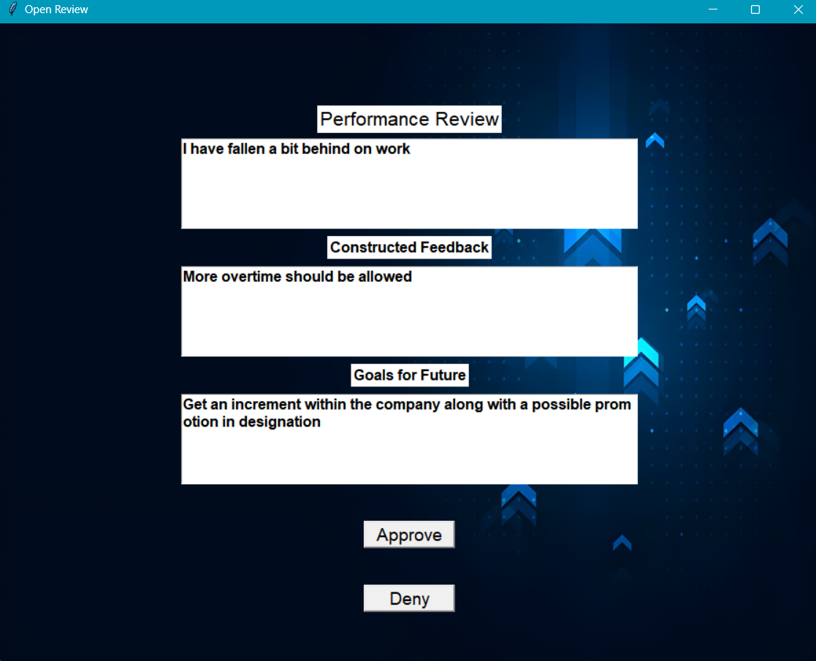  
  
**Figure.3.5.34. Approve review when selecting profile**

Figure.3.5.34: - This window represents the review of the manager. Also, with an option to approve or deny the request which is then send back to the same profile user. This makes communication more understanding and clearer.

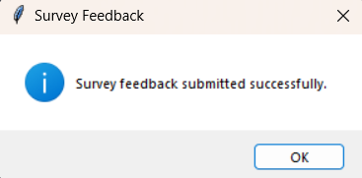

**Figure 3.5.35: Success Dialog**

Figure 3.5.35: - The dialog box that is presented to the user when the submit button is clicked and the new questions have been assigned in the DB.

34

Review Complaint: -

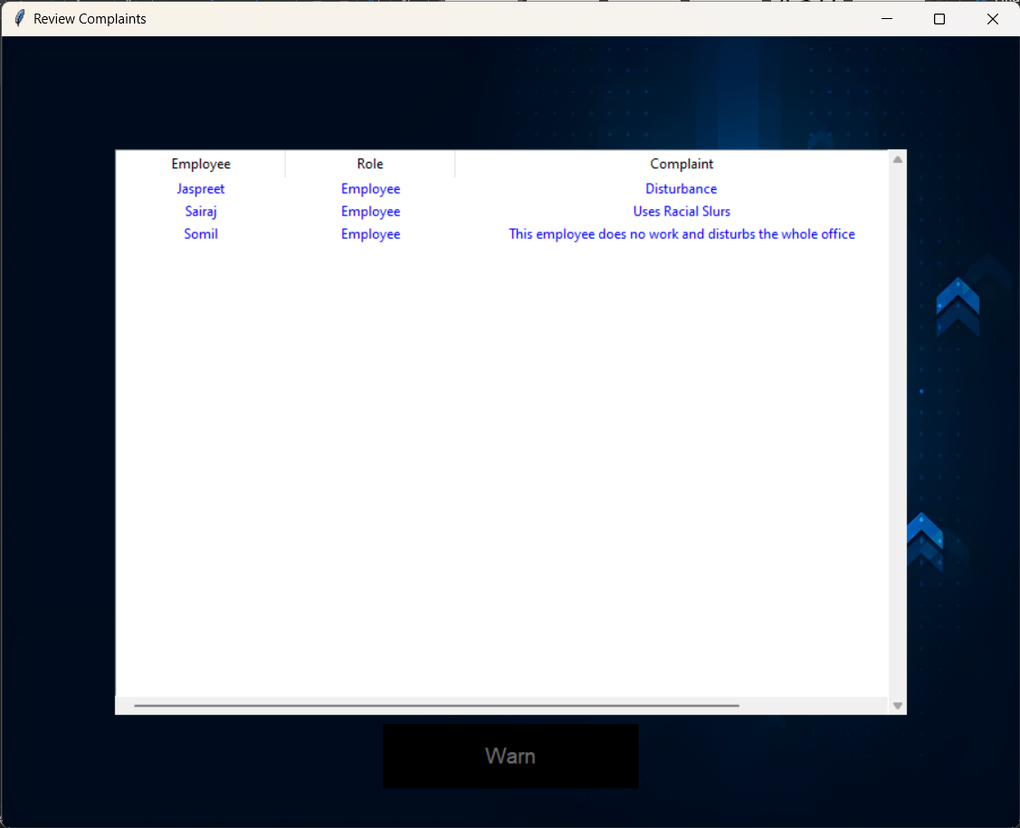

**Figure 3.5.36: Review Complaint**

Figure 3.5.36: - HR role can review the complaints regarding the employee which only be viewed by HR are observed. The details of the employee as well as the role of the employee is shown in the respective figure. With this the HR can directly give a warning statement to the employee regarding the matter personally.

35

View survey result: -

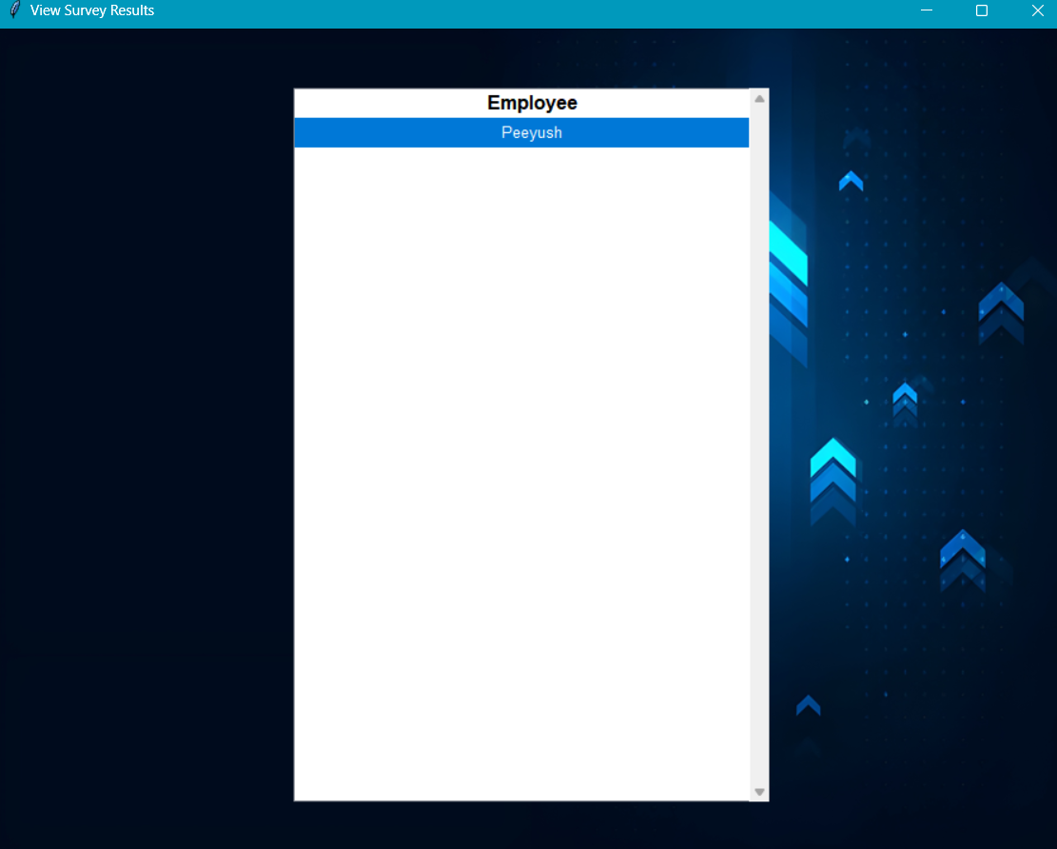

**Figure 3.5.37: View survey result**

Figure 3.5.37: - The window represents the results of the survey completed from every employee which provides the information to the HR regarding any issues directly. This helps the HR to get an insight of the environment problems faced by the employees.

36

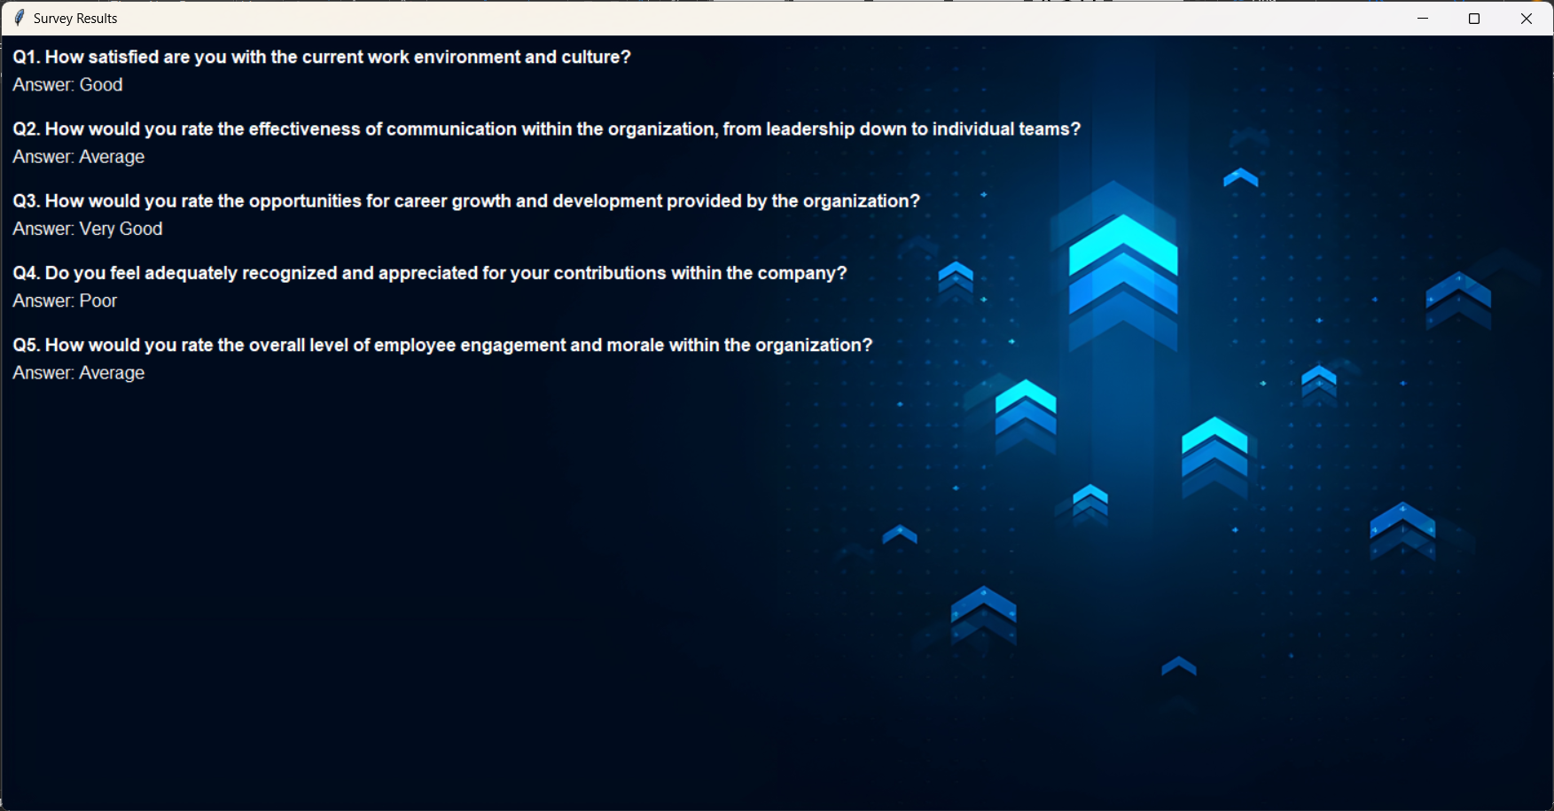

**Figure 3.5.38: View Results**

Figure 3.5.38: - Upon clicking on a particular profile which has submitted the survey answers, the HR can review the answers shown along with the questions.

37

Profile For HR: -

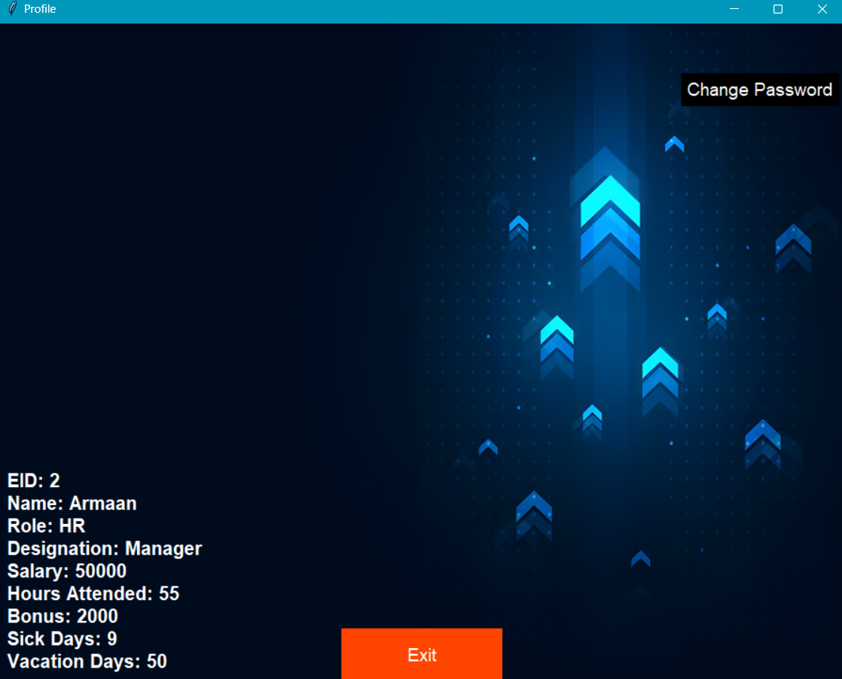

**Figure 3.5.39: HR Profile**

Figure 3.5.39: -This Profile screen represents the details for the HR which shows the Name, EID, Role, Designation, Salary, Hours Attended, Bonus and Sick days leave/ Vacation days leave. The user is also able to change its password through this screen.

38

Manager Window:

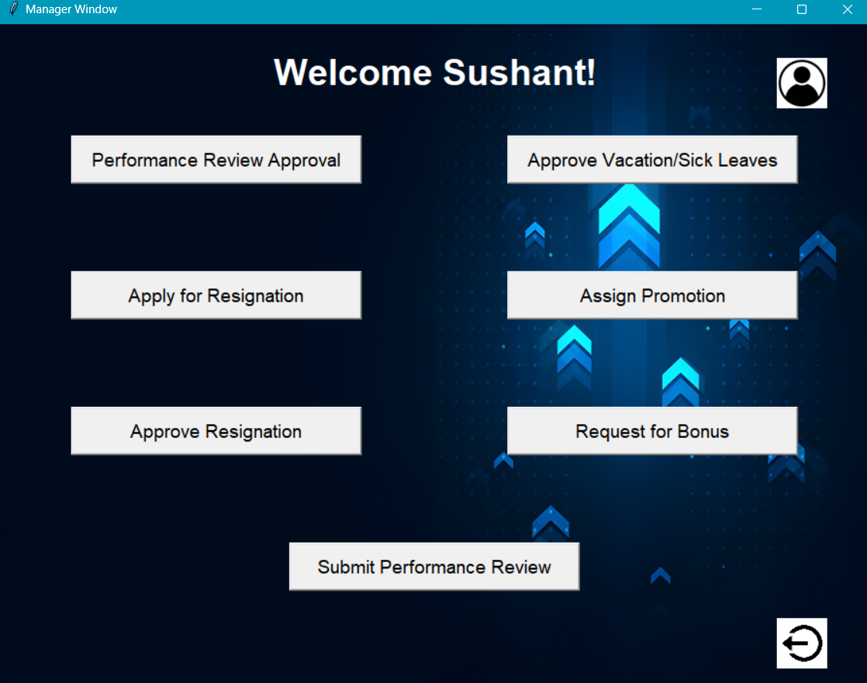

**Figure 3.5.40: Manager Window**

Figure 3.5.40: The window that is shown to the user who logs in at the manager level, the user has the options to approve performance reviews (figure 3.5.41), approve vacation/sick leaves (figure 3.5.43), apply for self resignation (figure 3.5.48), assign promotion for an employee (figure 3.5.49), approve an specific employee’s resignation request (figure 3.5.53), request bonus for an employee (figure 3.5.56) and submit their own performance review for the HR to check (figure 3.5.59). This window also has buttons to view the profile (figure 3.5.60) and to logout from the login which will take the user back to the main login screen (figure 3.5.1).

39

Performance Review Approval: -

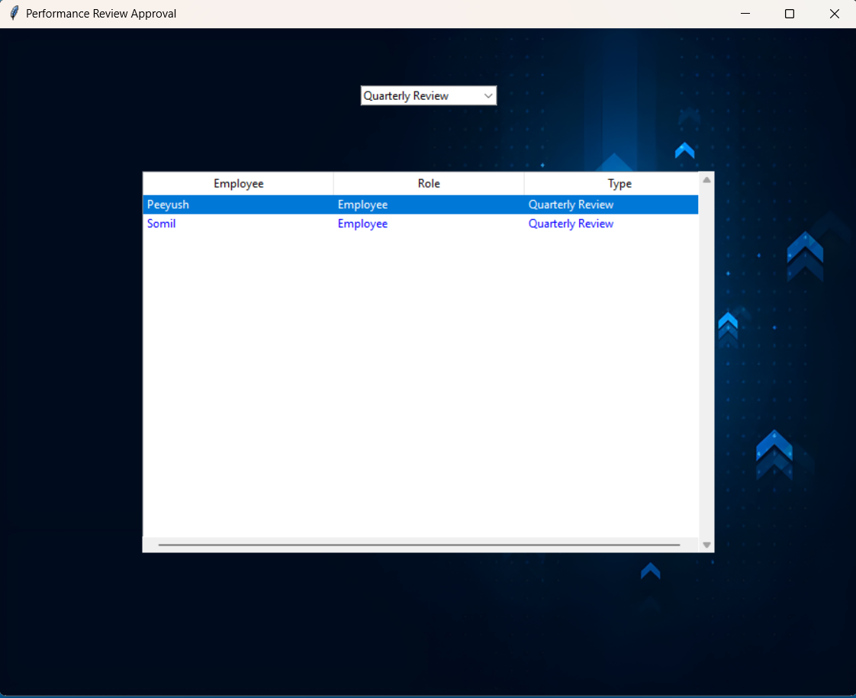

**Figure 3.5.41: Performance Review Approval**

Figure 3.5.41: - Opens a new window when the approve performance review button is clicked, this displays the list of employees who have filled their quarterly and annual reports separately, clicking each employee’s name will give the information they have filled, that performance review can then be approved or denied by the manager.

40

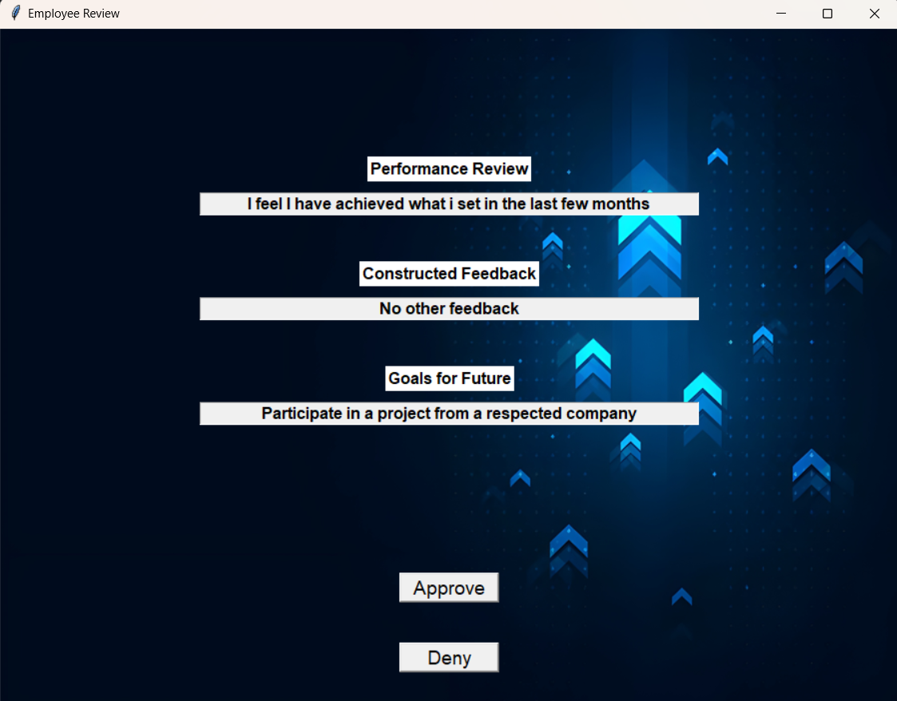

**Figure 3.5.42: Manager Window**

Figure 3.5.42: - Shows the details of the performance review filled in by the employee along with approve and deny buttons for the performance review.

41

Approve Vacations and Sick Leaves: -

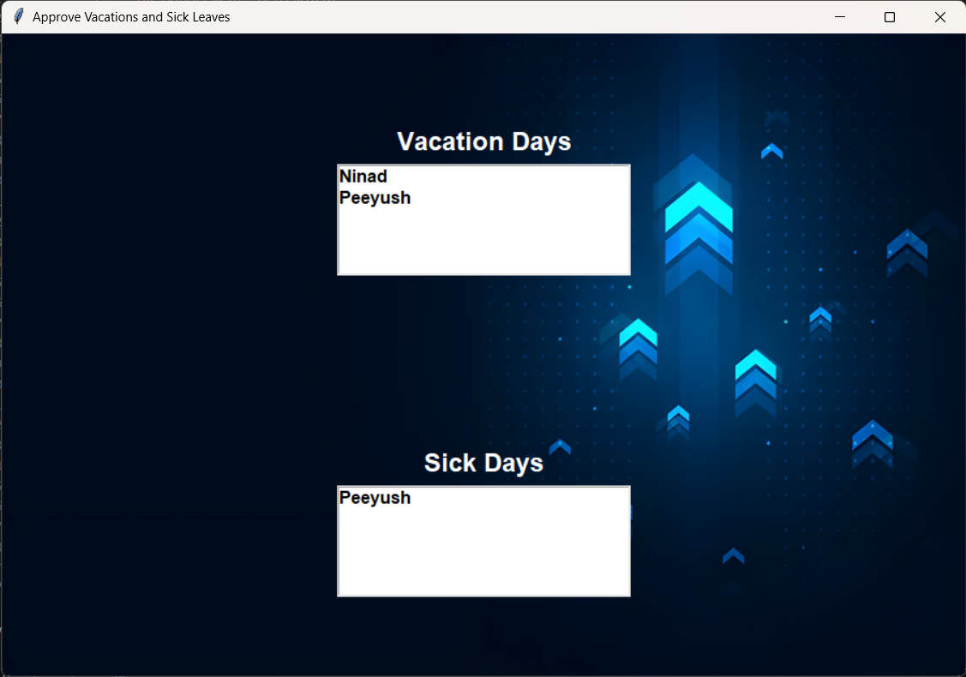

**Figure 3.5.43: Approve Vacation and Sick Leaves**

Figure 3.5.43: - The list of employees whose vacation and sick leave approvals are still pending will be shown in separate list here, the Manager can then click on each user’s name and view the details filled in.

Details for vacations days (figure 3.5.44) and sick days (figure 3.5.46) are shown separately to reduce confusion for the Manager.

42

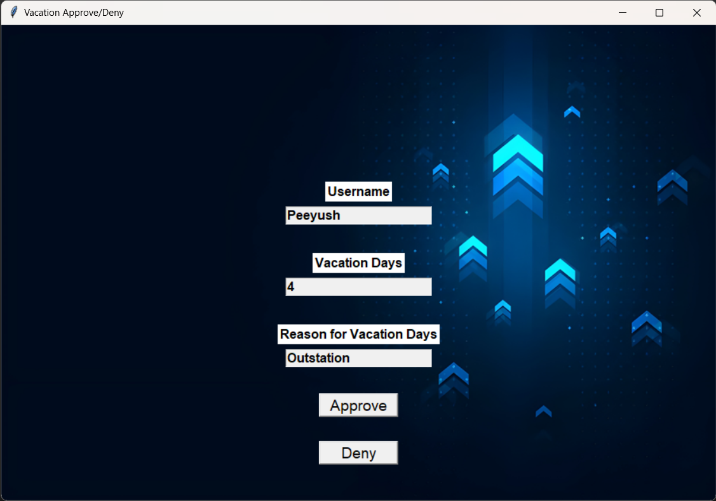

**Figure 3.5.44: Vacation Approve/deny**

Figure 3.5.44: - Shows the number of vacation days requested along with buttons to the approve or deny the request by the employee.

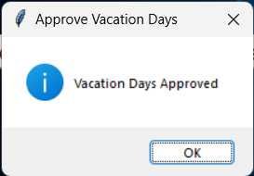

**Figure 3.5.45: Success Dialog**

Figure 3.5.45: - The prompt given to the manager after approval or denial of the request.

43

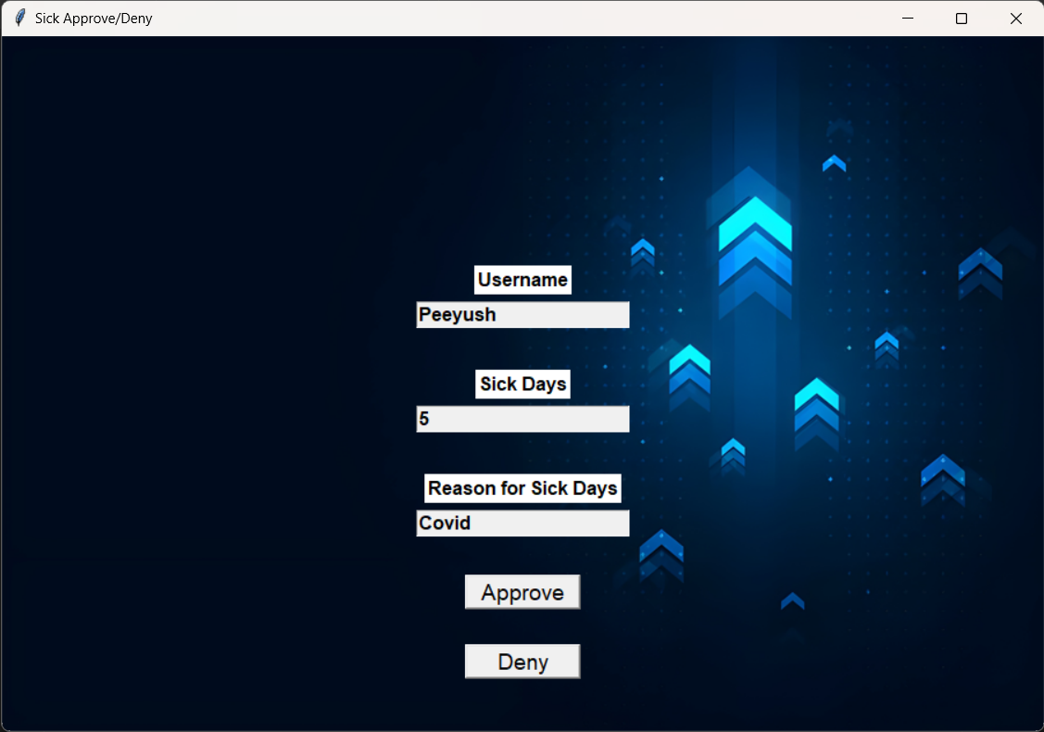

**Figure 3.5.46: Sick Approve/Deny**

Figure 3.5.46: - Shows the number of sick days requested along with buttons to the approve or deny the request by the employee.

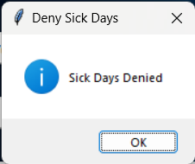

**Figure 3.5.47: Success Dialog**

Figure 3.5.47: - The prompt given to the manager after approval or denial of the request.

44

Apply for resignation: -

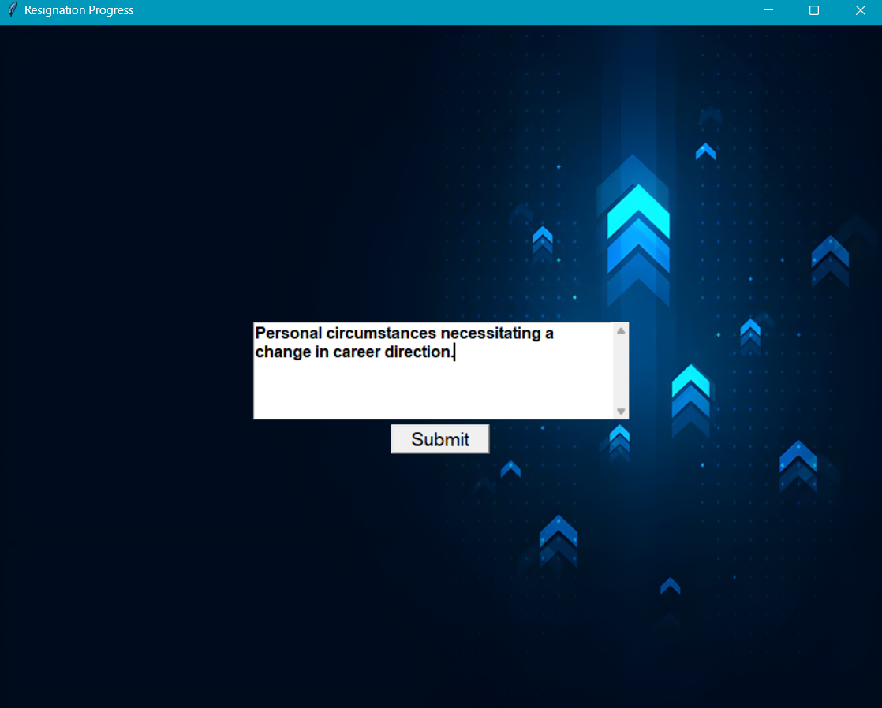

**Figure.3.5.48: Apply for resignation**

Figure 3.5.48: - Upon clicking apply for resignation this window will give you a textbox which when submitted will send your application for resignation.

45

Assign for promotion: -

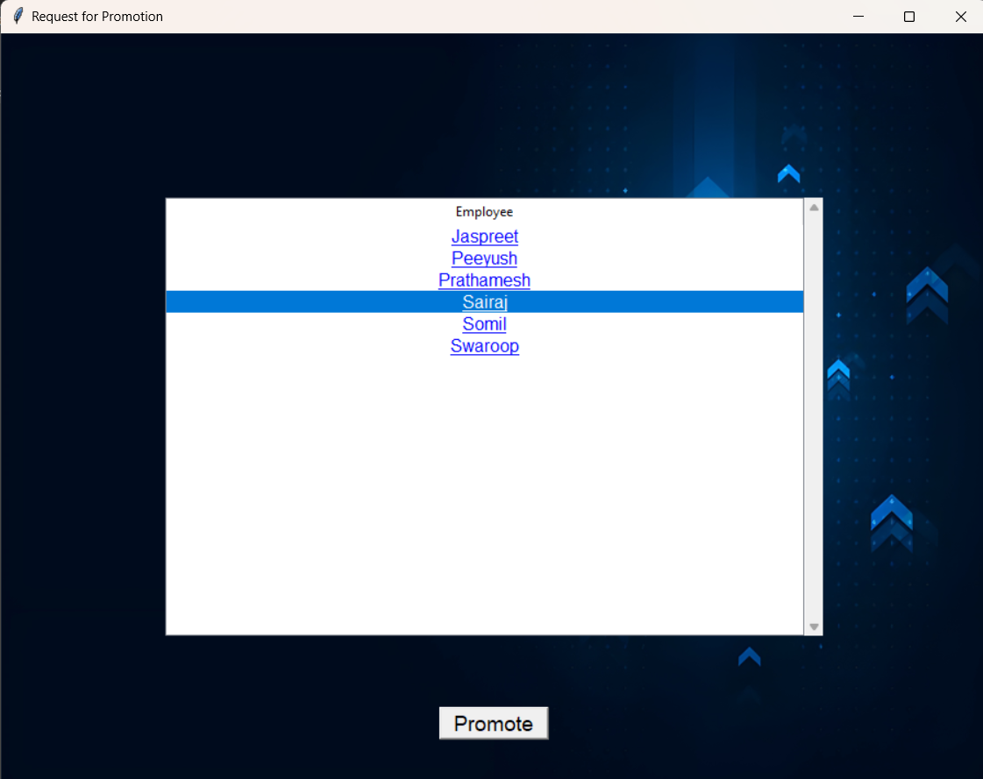

**Figure 3.5.49: Request For Promotion**

Figure 3.5.49: - Upon clicking the Approve promotion button a new window shows up with the list of employees whose promotion approval is pending, upon clicking the respective employee the approve button highlights itself which can then be clicked to approve the promotion.

46

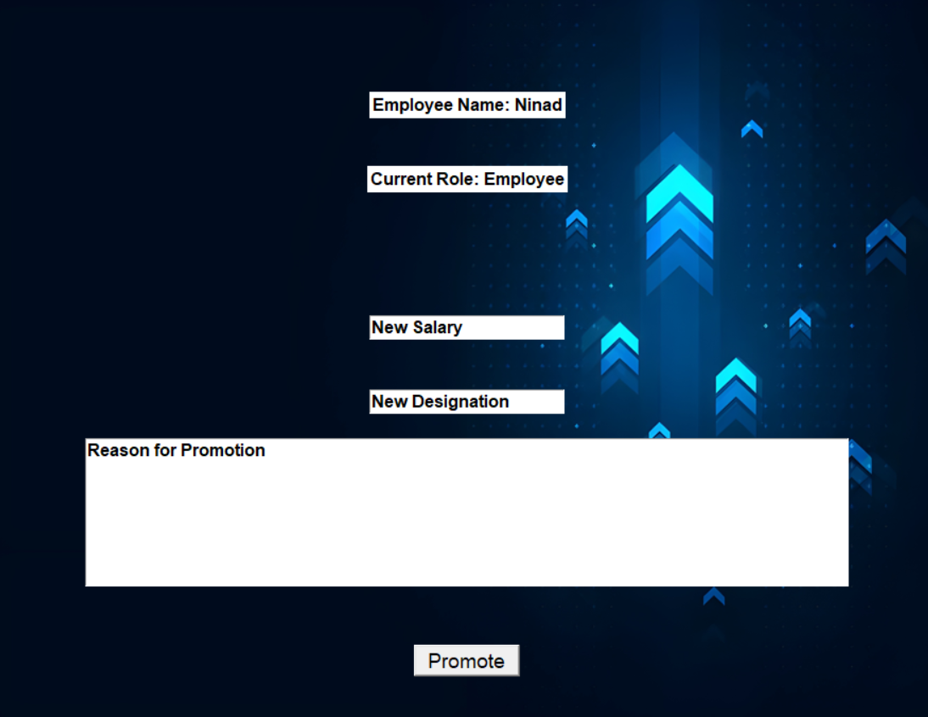

**Figure 3.5.50: Details of Promotion**

Figure 3.5.50: - In this figure with the approve of promotion the salary is updated and the reason for promotion is also stated accordingly with respect to the name and new designation of the Employee.

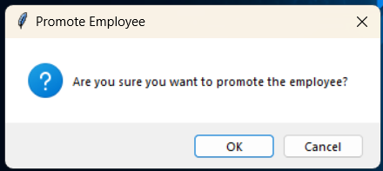

**Figure 3.5.51: Confirmation Dialog**

Figure 3.5.51: - Clicking the promote request button will show this success confirmation and the data will be updated in the DB.

47

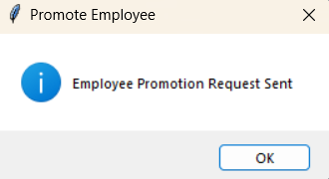

**Figure 3.5.52:** Success Dialog

Figure 3.5.52: - Clicking the ok request button will show this success confirmation and the data will be updated in the DB.

Approve resignation: -

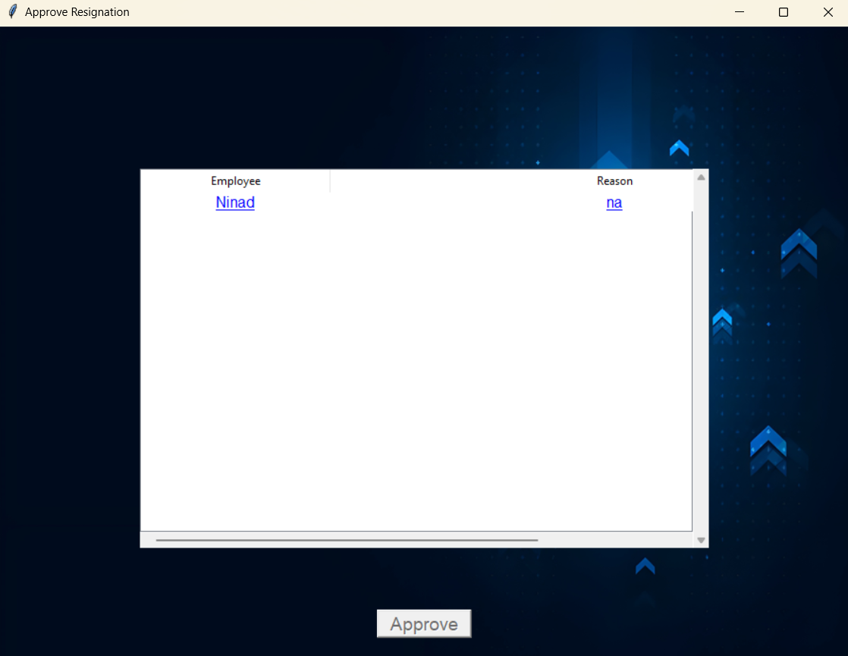

**Figure 3.5.53: Approve Resignation**

Figure 3.5.53: - Upon clicking the Approve resignation button a new window shows up with the list of employees whose resignation approval is pending, upon clicking the respective employee the approve button highlights itself which can then be clicked to approve the resignation.

48

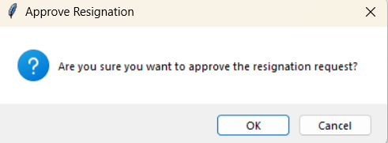

**Figure 3.5.54: Confirmation Dialog**

Figure 3.5.54: - The final confirmation dialog which is shown to the Manger to approve the resignation request, upon approving it, it will further go to the HR for final approval and then the login will be removed.

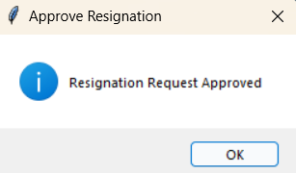

**Figure 3.5.55:** Success Dialog

Figure 3.5.55: - Clicking the ok request button will show this success confirmation and the data will be updated in the DB.

49

Request for Bonus: -

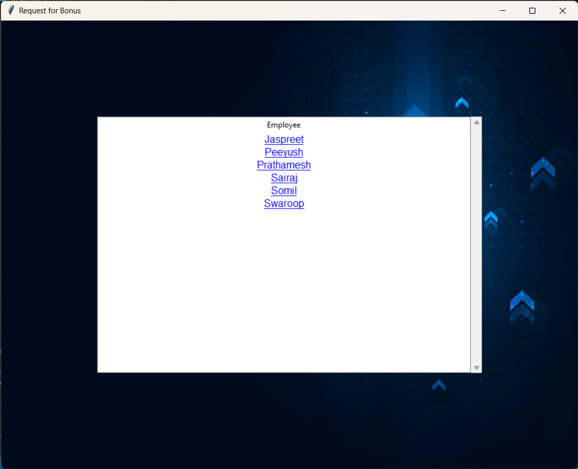

**Figure 3.5.56: Request for Bonus**

Figure 3.5.56: - When the Request for Bonus button is clicked, this new window is shown to the Manager, from where the they can choose which employee deserves the bonus and click on that employee’s login.

50

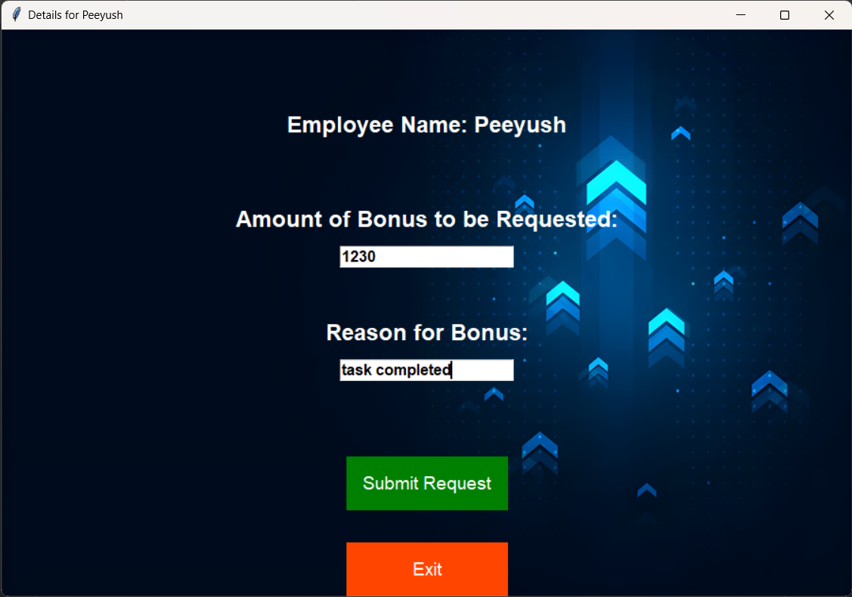

**Figure 3.5.57: Details for Employee**

Figure 3.5.57: - This new window gives the option for the amount of bonus to be requested by the manager for the employee along with the reason for this. There are also two buttons to submit the request or exit from that window.

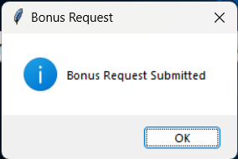

**Figure 3.5.58:** Success Dialog

Figure 3.5.58: - Clicking the submit request button will show this success confirmation and the data will be updated in the DB.

51

Submit Performance Review: -

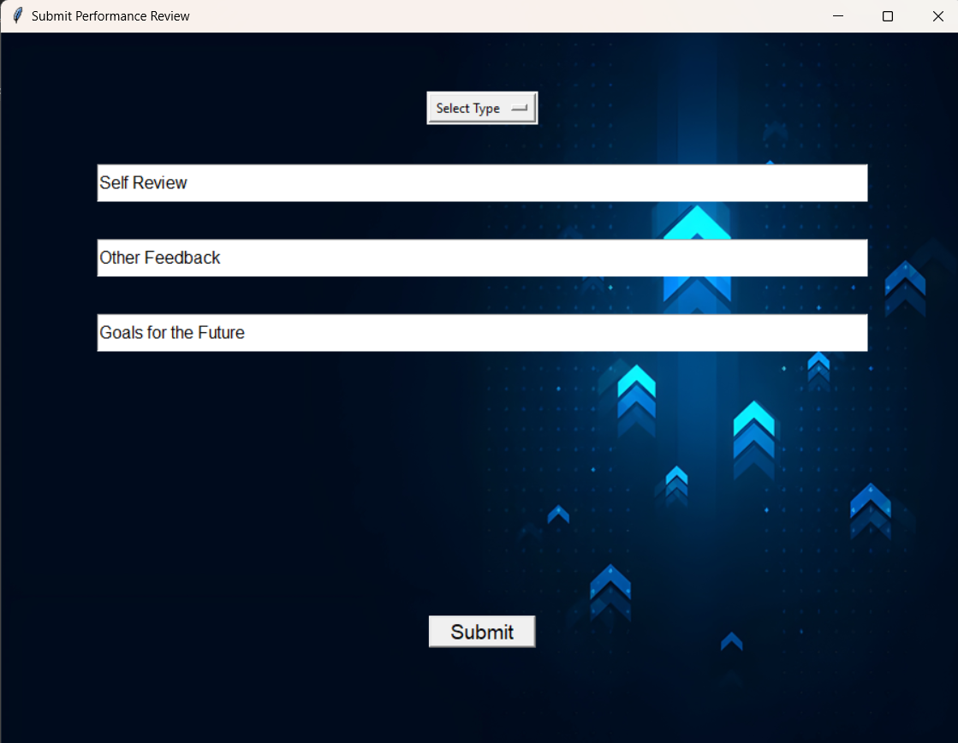

**Figure 3.5.59: submit Performance Review**

Figure 3.5.59: - User can provide reviews regarding any kind of concern. This will help the HR to clear the vision and the expectation of the Manager future growth and development goals. Plus, the manager can provide feedback about others regarding there positive or negative concerns respectively.

52

Profile Window for manager: -

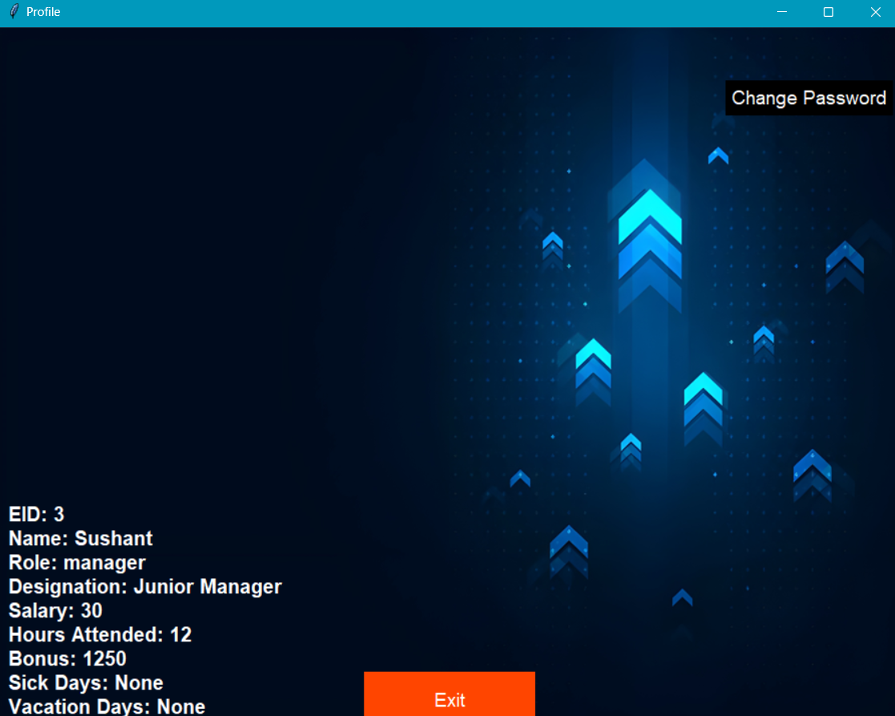

**Figure 3.5.60: Manager Window**

Figure 3.5.60: - This Profile screen represents the details for the Manager which shows the Name, EID, Role, Designation, Salary, Hours Attended, Bonus and Sick days leave/ Vacation days leave. The user is also able to change its password through this screen

53

Employee Window: -

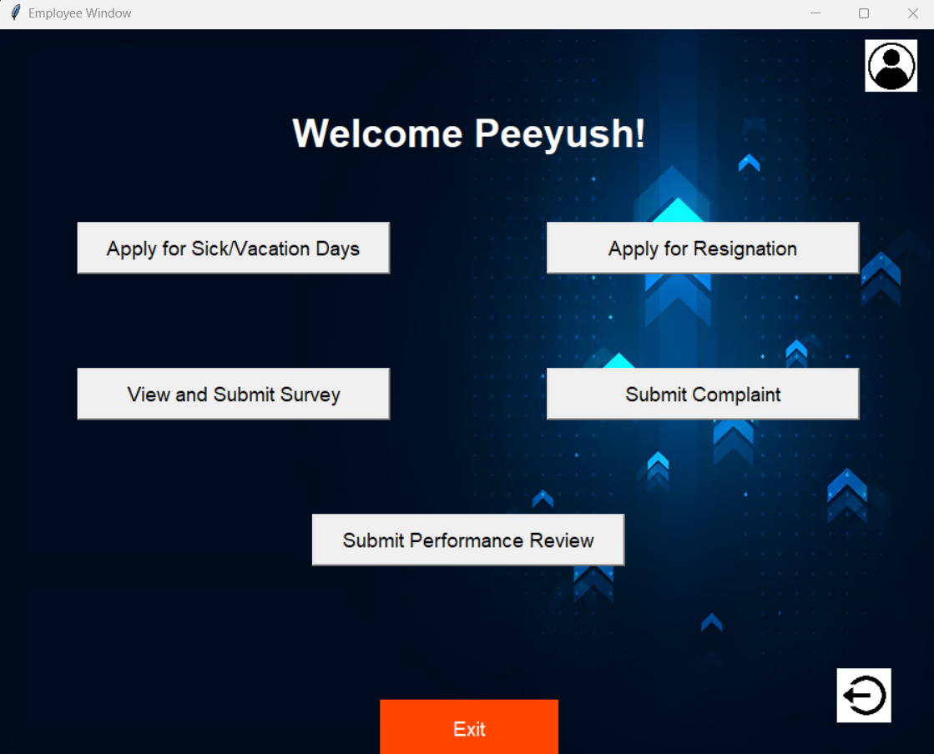

**Figure 3.5.61: Employee Window**

Figure 3.5.61: - The window shown to the employee role and permission level, it consists of options to Apply for sick/vacation days (figure 3.5.62), apply for resignation (figure 3.5.65), view and submit surveys created by the HR (figure 3.5.67), submit complaints (figure 3.5.69) and submit their own performance review (figure 3.5.71). Like other windows this window also includes the profile button to view the profile details (figure 3.5.73) and a logout button that will take the user directly to the main login page (figure 3.5.1).

54

Apply For Sick/Vacation Days: -

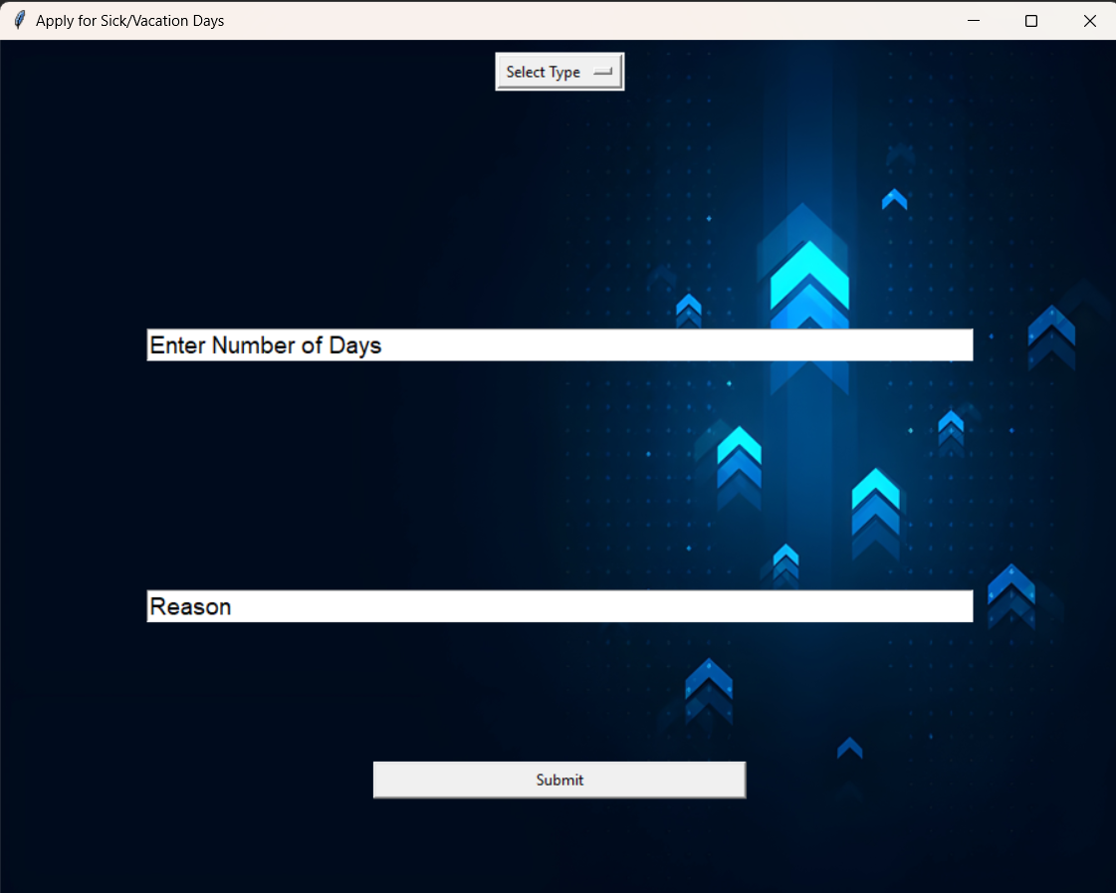

**Figure 3.5.62: Apply For Sick/Vacation Days**

Figure 3.5.62: - This window is opened when the employee clicks on the Apply for Sick/Vacation days button, it gives the employee the options to choose between the sick (figure 3.5.64) and vacation days request along with the number of days to be requested and the reason for the request.

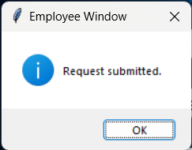

**Figure 3.5.63: Success Dialog**

Figure 3.5.63: - The dialog box shown when the employee submits the request and the data has been pushed to the DB.

55

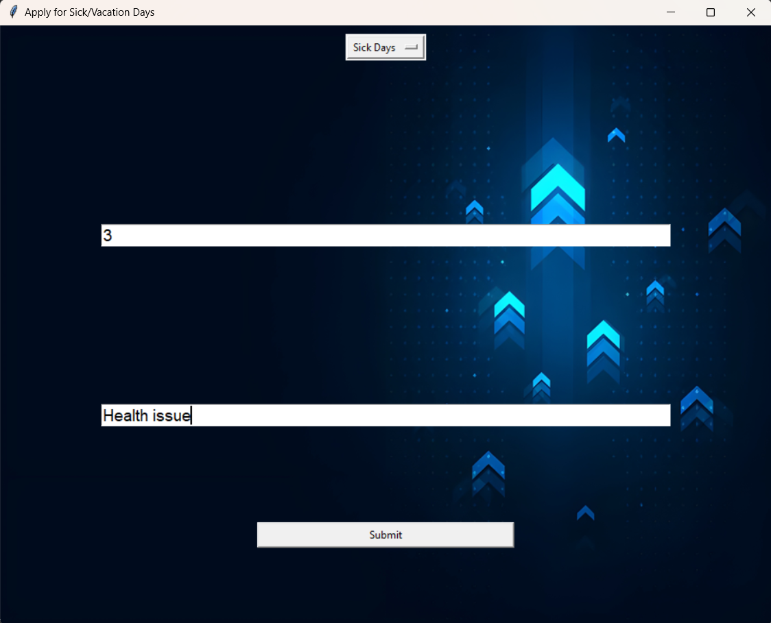

**Figure 3.5.64: Apply for Sick/Vacation Days**

56

Apply for Resignation: -

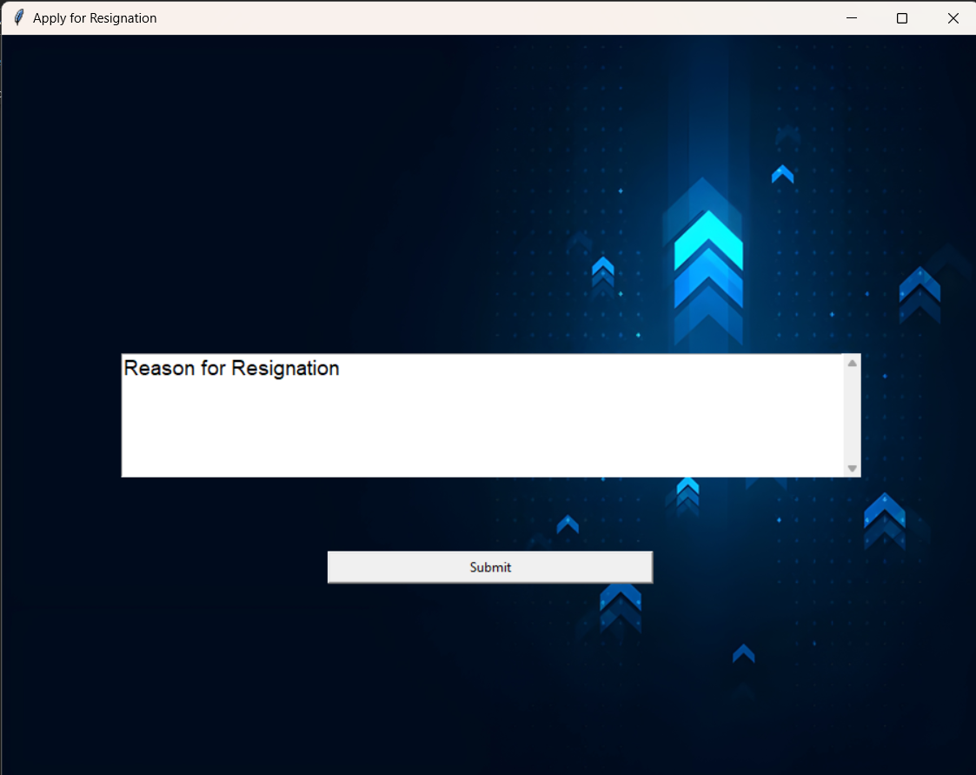

**Figure 3.5.65: Apply for Resignation**

Figure 3.5.65: - The window shown when the user clicks on the apple for resignation button, which ask the user for the to apply for resignation (minimum 2 weeks’ notice) along with the reason for the resignation and a submit button to submit the request.

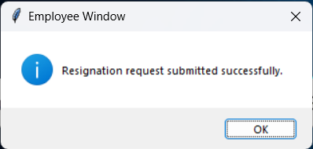

**Figure 3.5.66: Success Dialog**

Figure 3.5.66: - The dialog box shown when the user has applied for the Resignation by clicking on the submit button.

57

View and Submit Survey: -

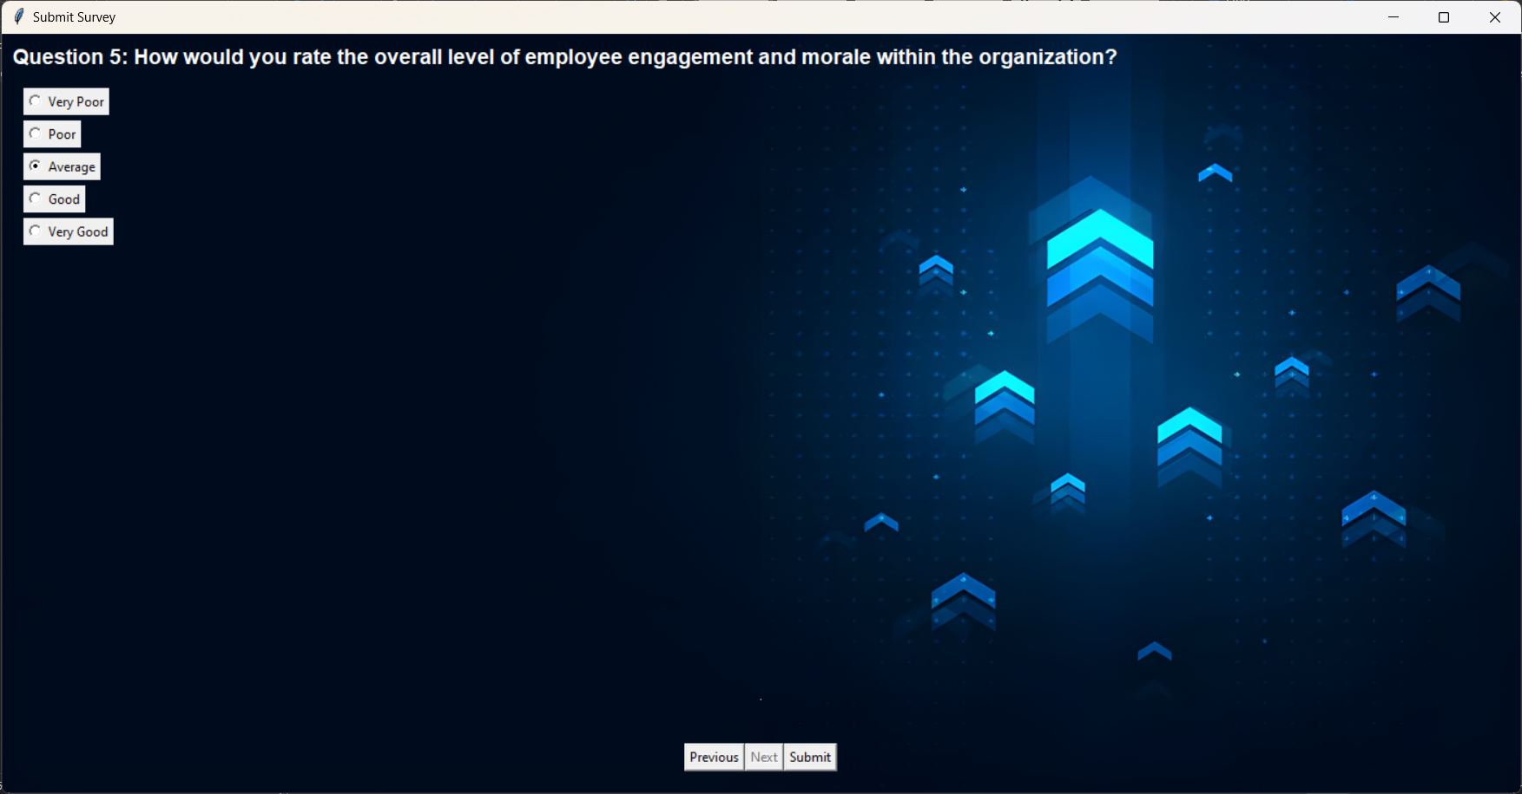

**Figure 3.5.67: Submit Survey**

Figure 3.5.67: - The window shown when the user clicks on the submit survey button to fill the survey set by the HR for the employees. The questions are displayed along with the question number and the radio buttons for the options, at the bottom of the window there are 3 more buttons for previous, next and submit.

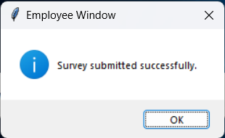

**Figure 3.5.68:** Success Dialog

Figure 3.5.68: - When the user submits the survey, the Survey submitted window is shown and the data is then stored in the DB.

58

Submit Complaint: -

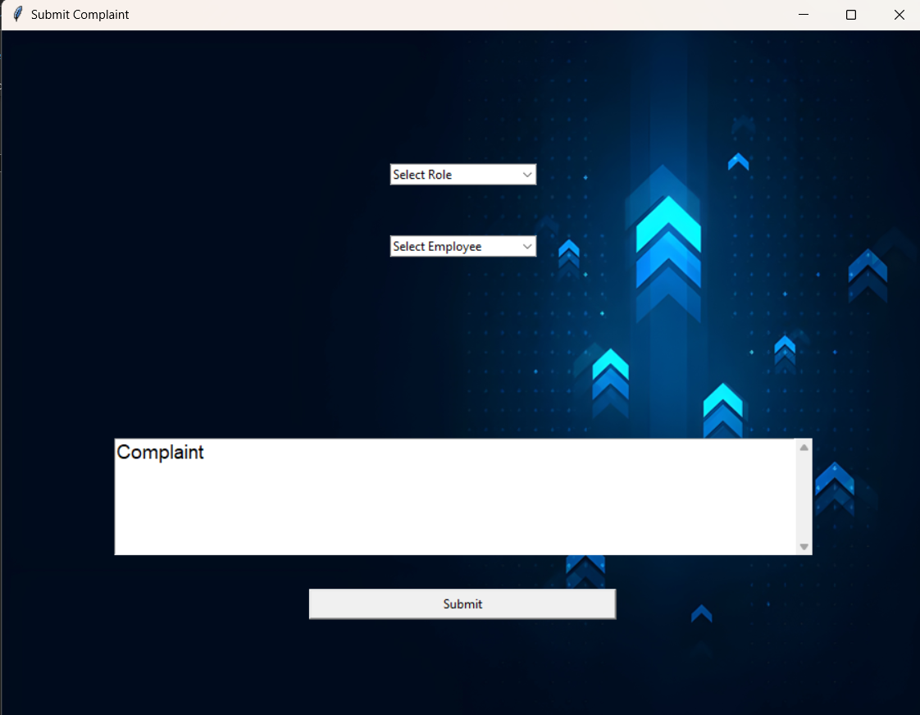

**Figure 3.5.69: Submit Complaint**

Figure 3.5.69: - When an employee clicks on the submit complaint button this window is created which gives 2 input boxes for the name of the employee along with the reason for the complaint, after the two input boxes there is a submit button.

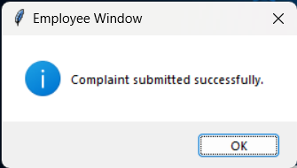

**Figure 3.5.70: Success Dialog**

Figure 3.5.70: - When the submit button is pressed it shows a success dialog box and sends the data to be stored in the DB.

59

Submit Performance Review: -

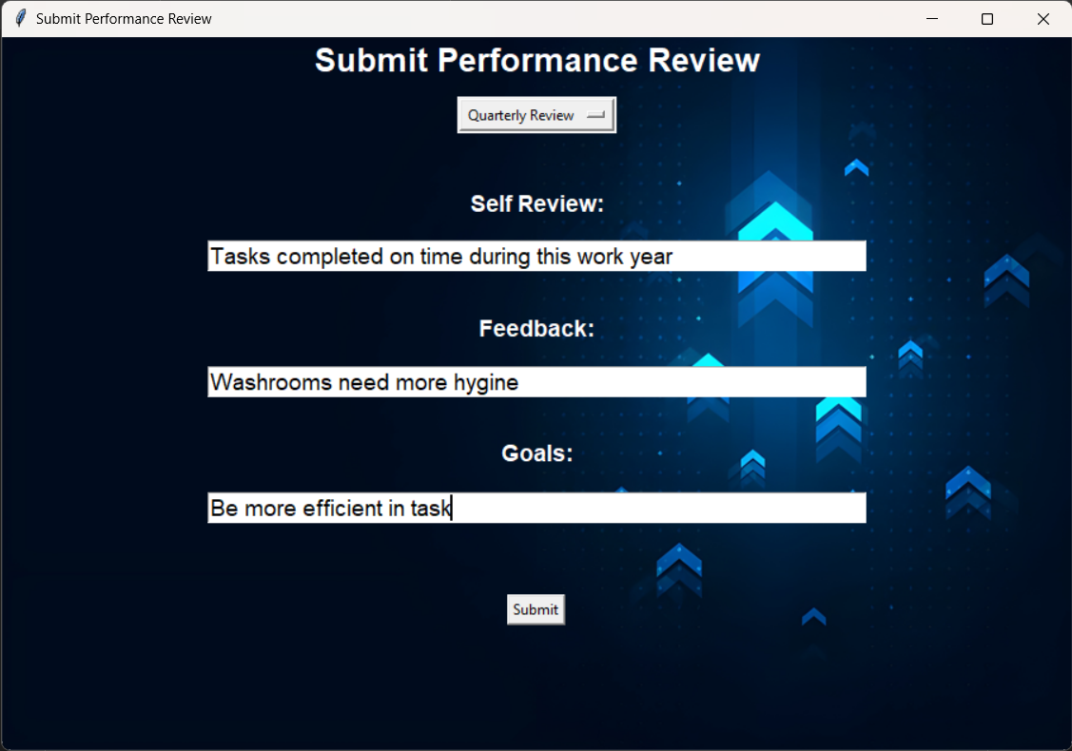

**Figure 3.5.71: Submit Performance Review**

Figure 3.5.71: - When the Submit performance review button is clicked this window is shown to the user which gives the option to select from quarterly review and annual review, along with 3 input boxes for their self-review, feedback for the company and future self-goals, below the input boxes is a submit button.

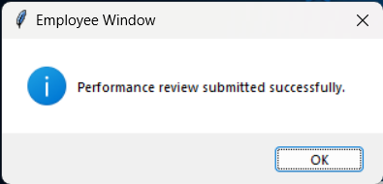

**Figure 3.5.72:** Success Dialog

Figure 3.5.72: - When the submit button is clicked the success dialog is shown and the data is stored in the DB.

60

Profile For Employee: -

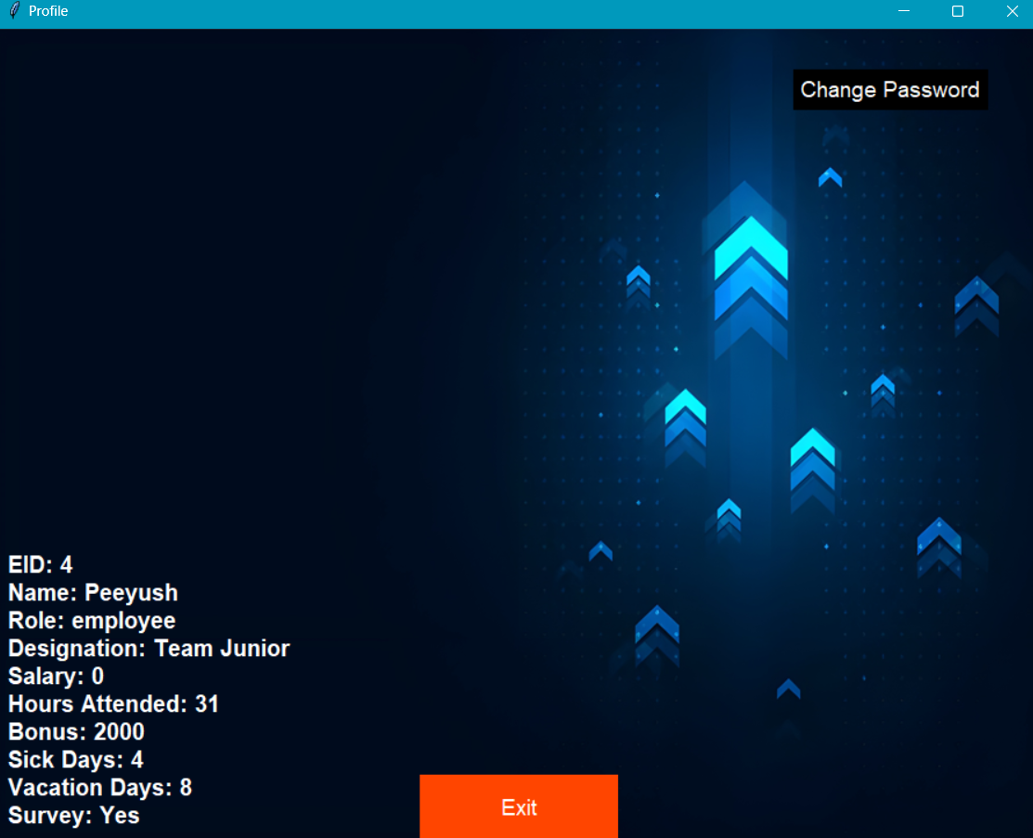

**Figure 3.5.73: Profile For Employee**

Figure 3.5.73: - This Profile screen represents the details for the Employee which shows the Name, EID, Role, Designation, Salary, Hours Attended, Bonus and Sick days leave/ Vacation days leave. The user is also able to change its password through this screen.

61

4. Conclusion and Future Scope: -

Conclusion: -

The conclusion for an Enhanced E-HR system can highlight its significance in streamlining organizational processes, enhancing employee engagement, and optimizing HR functionalities. It underscores the system's role in promoting efficiency, transparency, and compliance within the organization. Additionally, it may emphasize the importance of ongoing evaluation, feedback mechanisms, and adaptation to evolving HR needs and technological advancements. In conclusion, implementing and maintaining an effective Enhanced E-HR system can significantly contribute to the overall success and sustainability of the organization in today's dynamic and competitive business environment.

Future Scope: -

The future scope of Enhanced E-HR systems is promising and likely to evolve in several key areas:

1. User Authentication and Authorization: Implement more robust user authentication mechanisms such as two-factor authentication (2FA) or OAuth for enhanced security. Also, refine the authorization system to ensure that users only have access to the features and data relevant to their role.
2. User Interface Enhancements: Improve the user interface with modern design principles, responsiveness for different screen sizes, and accessibility features to cater to a wider range of users.
3. Advanced Reporting and Analytics: Integrate data visualization tools to generate comprehensive reports and analytics on employee performance, HR metrics, and managerial insights. This can help in making data-driven decisions and identifying areas for improvement.
4. Integration with External Systems: Enable integration with other enterprise systems such as payroll management, CRM, or project management tools to streamline data exchange and improve workflow efficiency.
5. Mobile Application: Develop a mobile application version of the platform to enable employees and managers to access key features on the go, such as submitting performance reviews, viewing schedules, or checking HR updates.

62

5.REFERENCE

1. Sohail Ahmed, XingKE ,“Human Resource Management: Employees Career Development Impact on Organizational Performance” , Yunnan, China 2016

2. Hewage H.A.S.S, Hettiarachchi K.U, Jayarathna K.M.J.B, Hasintha K.P.C., A. N. Senarathne, J. Wijekoon, “Smart Human Resource Management System to Maximize Productivity” ,Malabe Sri Lanka , 2020

3. Lina Zhang ,“Research on the Application of Human Resources Information Management System under Computer Big iData Technology” , Dalian China , January 2023

4. Yawen Mi, Enduo Gao ,“Design of Human Resource Management System Based on Java EE”, Shanghai China, June 2023

5. D Chavan, A Kiran ,“Dot Diffusion Block Truncation Coding For Satellite Image Retrieval” ,International journal of Computer Applications 124 (4), 24-29

6. D Chavan ,KA Bhandari , “A New Block Truncation Coding (NBTC) For Satellite Image Retrieval Using Dot Diffusion”, IJSER6 (ISSN2229-5518), 9

7. Shayista Majeed , Sabzar Ahmad Peerzadah and Sabiya Mufti, “Electronic Human Resource Management: Need of the Hour", University of Kashmir, July 2020

8. A.S.Syed Navaz, A.S.Syed Fiaz , C.Prabhadevi , V.Sangeetha , S.Gopalakrishnan, “Human Resource Management System”, Sona College of Technology/ Anna University, February 2013

63